DEFTRP004 Operate a vehicle using night fighting equipment (NFE)
Release: 1

DEFTRP004 Operate a vehicle using night fighting equipment (NFE)

Modification History
Release | Comments
1 | This unit was released in DEF Defence Training Package release 1.0 and meets the Standards for Training Packages.  This unit supersedes and is equivalent to DEFTP004B Operate a vehicle using night fighting equipment (NFE).  - Unit code updated  - Content and formatting updated to comply with the new standards  - All PC transitioned from passive to active voice

Application
This unit describes the skills required to operate a vehicle, including all wheeled road transport vehicles, using night fighting equipment (NFE) as an aid to driving at night in limited or no light under field conditions. NFE is a collective term that refers to image intensification equipment. It is used by the driver in limited or no light conditions to enhance and improve natural vision at night, when other forms of lighting are prohibited by the operational situation. The driver is required to perform all of the standard driving activities using NFE including vehicle preparation, serviceability checks, driving and navigation. In addition, the driver, while dismounted, is required to direct another vehicle using hand signals.
This unit was developed for military drivers in a threat environment, but is applicable to any individuals who work in this field.
The skills and knowledge described in this unit must be applied within the legislative, regulatory and policy environment in which they are carried out. Organisational policies and procedures must be consulted and adhered to.
Those undertaking this unit would work independently or as part of a team, under direct and indirect supervision, use discretion and judgement, and take responsibility for the quality of their output. They would perform routine tasks in a broad range of unpredictable contexts.
No licensing, legislative or certification requirements apply to unit at the time of publication.

Competency Field
Transport

Elements and Performance Criteria
ELEMENTS | PERFORMANCE CRITERIA
Elements describe the essential outcomes | Performance criteria describe the performance needed to demonstrate achievement of the element. Where bold italicised text is used, further information is detailed in the range of conditions section.
1. Prepare a vehicle for driving at night using NFE | 1.1 Inspect NFE for driving and set up.  1.2 Conduct serviceability check of the vehicle using NFE and rectify and/or report faults.  1.3 Configure vehicle for night driving using NFE.
2. Direct a vehicle using NFE | 2.1 Identify, obtain and check appropriate NFE for serviceability.  2.2 Report any faults with NFE to appropriate personnel, rectify and/or return to store.  2.3 Direct vehicle as an external guide using NFE.  2.4 Retrieve and check NFE and return to storage area with any faults rectified and/or reported.
3. Drive a vehicle using NFE | 3.1 Drive vehicle singularly and in convoy using NFE.  3.2 Respond to directions from an external guide while driving with NFE.  3.3 Navigate vehicle while driving with NFE.  3.4 Carry out contingency actions on failure of NFE.

Foundation Skills
The foundation skills demands of this unit have been mapped for alignment with the Australian Core Skills Framework (ACSF). The following tables outline the performance levels indicated for successful attainment of the unit.

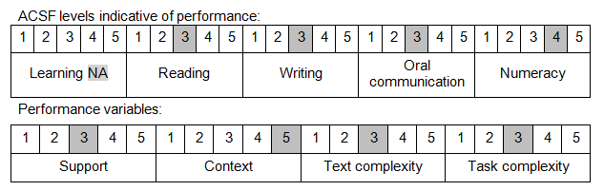

Further information on ACSF and the foundation skills underpinning this unit can be found in the Foundation Skills Guide on the GSA website.

Unit Mapping Information
This unit supersedes and is equivalent to DEFTP004B Operate a vehicle using night fighting equipment (NFE).

Links
Companion Volume implementation guides are found in VETNet - https://vetnet.gov.au/Pages/TrainingDocs.aspx?q=6bdbab1e-11ed-4bc9-9cba-9e1a55d4e4a9
Companion Volume implementation guides are found in VETNet - https://vetnet.gov.au/Pages/TrainingDocs.aspx?q=6bdbab1e-11ed-4bc9-9cba-9e1a55d4e4a9
Companion Volume implementation guides are found in VETNet - https://vetnet.gov.au/Pages/TrainingDocs.aspx?q=6bdbab1e-11ed-4bc9-9cba-9e1a55d4e4a9

