DEFTRP003 Operate a vehicle over difficult terrain
Release: 1

DEFTRP003 Operate a vehicle over difficult terrain

Modification History
Release | Comments
1 | This unit was released in DEF Defence Training Package release 1.0 and meets the Standards for Training Packages.  This unit supersedes and is equivalent to DEFTP003B Operate a vehicle over difficult terrain.  - Unit code updated  - Content and formatting updated to comply with the new standards  - All PC transitioned from passive to active voice

Application
This unit describes the skills required to prepare a vehicle and drive over difficult terrain, including cross country and other off road situations. This involves the application of low risk driving techniques, dealing with hazards, and the assessment (where necessary) and the safe negotiation of obstacles, including water courses such as rivers and streams. The driver must be able to deal with contingencies related to an emergency that may occur in the hazardous situations that may be encountered in driving over difficult terrain under field conditions.
This unit was developed for military drivers in a threat environment, but is applicable to any individuals who work in this field.
The skills and knowledge described in this unit must be applied within the legislative, regulatory and policy environment in which they are carried out. Organisational policies and procedures must be consulted and adhered to.
Those undertaking this unit would work independently or as part of a team, under direct and indirect supervision, use discretion and judgement, and take responsibility for the quality of their output. They would perform complex tasks in a broad range of unpredictable contexts.
No licensing, legislative or certification requirements apply to unit at the time of publication.

Competency Field
Transport

Elements and Performance Criteria
ELEMENTS | PERFORMANCE CRITERIA
Elements describe the essential outcomes | Performance criteria describe the performance needed to demonstrate achievement of the element. Where bold italicised text is used, further information is detailed in the range of conditions section.
1. Prepare a vehicle for driving over difficult terrain | 1.1 Conduct serviceability check of a vehicle for driving over difficult terrain.  1.2 Rectify and/or report any vehicle faults.  1.3 Configure vehicle for driving in difficult terrain.
2. Drive over difficult terrain | 2.1 Conduct reconnaissance of the terrain to be traversed by map and/or visual observation identifying potential hazards, including entry and exit routes, obstructions and bypasses.  2.2 Plan task and discuss potential hazards and contingency actions with a supervisor.  2.3 Reconfigure vehicle and adjust the load as necessary.  2.4 Apply low risk driving techniques when driving over difficult terrain.  2.5 Apply vehicle contingency actions when required to deal with accidents and emergencies that may occur when negotiating hazards.
3. Refurbish vehicle | 3.1 Inspect vehicle for damage after hazardous situations are negotiated and on completion of the task.  3.2 Rectify and/or report faults and damage to the supervisor.  3.3 Clean and reconfigure vehicle and load as necessary for standard driving conditions.

Foundation Skills
The foundation skills demands of this unit have been mapped for alignment with the Australian Core Skills Framework (ACSF). The following tables outline the performance levels indicated for successful attainment of the unit.

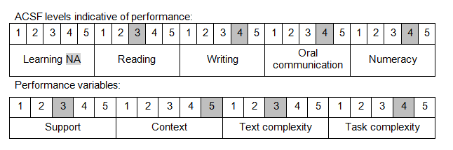

Further information on ACSF and the foundation skills underpinning this unit can be found in the Foundation Skills Guide on the GSA website.

Unit Mapping Information
This unit supersedes and is equivalent to DEFTP003B Operate a vehicle over difficult terrain.

Links
Companion Volume implementation guides are found in VETNet - https://vetnet.gov.au/Pages/TrainingDocs.aspx?q=6bdbab1e-11ed-4bc9-9cba-9e1a55d4e4a9
Companion Volume implementation guides are found in VETNet - https://vetnet.gov.au/Pages/TrainingDocs.aspx?q=6bdbab1e-11ed-4bc9-9cba-9e1a55d4e4a9
Companion Volume implementation guides are found in VETNet - https://vetnet.gov.au/Pages/TrainingDocs.aspx?q=6bdbab1e-11ed-4bc9-9cba-9e1a55d4e4a9

