DEFTRP002 Operate a vehicle at night
Release: 1

DEFTRP002 Operate a vehicle at night

Modification History
Release | Comments
1 | This unit was released in DEF Defence Training Package release 1.0 and meets the Standards for Training Packages.  This unit supersedes and is equivalent to DEFTP002B Operate a vehicle at night.  - Unit code updated  - Content and formatting updated to comply with the new standards  - All PC transitioned from passive to active voice

Application
This unit describes the skills required to drive, navigate and direct a vehicle at night under field conditions using white, reduced and blackout lighting where the threat(s) by an adversary or enemy may prohibit the full use of normal vehicle headlights, tail lights and interior lighting. In these circumstances, to assist in the control, operation and navigation of the vehicle, the driver may use guides and other aids, including specialist ‘blackout’ lighting equipment fitted to vehicles.
This unit was developed for military drivers in a threat environment, but is applicable to any individuals who work in this field.
The skills and knowledge described in this unit must be applied within the legislative, regulatory and policy environment in which they are carried out. Organisational policies and procedures must be consulted and adhered to.
Those undertaking this unit would work independently or as part of a team, under direct and indirect supervision, use discretion and judgement, and take responsibility for the quality of their output. They would perform routine tasks in a broad range of unpredictable contexts.
No licensing, legislative or certification requirements apply to unit at the time of publication.

Competency Field
Transport

Elements and Performance Criteria
ELEMENTS | PERFORMANCE CRITERIA
Elements describe the essential outcomes | Performance criteria describe the performance needed to demonstrate achievement of the element. Where bold italicised text is used, further information is detailed in the range of conditions section.
1. Prepare a vehicle for driving at night | 1.1 Conduct serviceability check of vehicle and any external aids to night driving.  1.2 Rectify and report any faults.  1.3 Configure vehicle for night driving.
2. Drive a vehicle at night | 2.1 Drive vehicle at night using various types of lighting and external aids in different types of terrain, road and light conditions.  2.2 Respond to directions from a co-driver and a guide, both with and without the assistance of external aids.  2.3 Navigate vehicle at night using navigational equipment.
3. Direct a vehicle at night | 3.1 Identify, obtain and check appropriate external aids for serviceability.  3.2 Rectify or report any vehicle faults.  3.3 Direct vehicle using external aids.  3.4 Retrieve and check aids and return external to storage area.

Foundation Skills
The foundation skills demands of this unit have been mapped for alignment with the Australian Core Skills Framework (ACSF). The following tables outline the performance levels indicated for successful attainment of the unit.

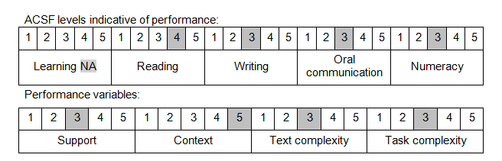

Further information on ACSF and the foundation skills underpinning this unit can be found in the Foundation Skills Guide on the GSA website.

Unit Mapping Information
This unit supersedes and is equivalent to DEFTP002B Operate a vehicle at night.

Links
Companion Volume implementation guides are found in VETNet - https://vetnet.gov.au/Pages/TrainingDocs.aspx?q=6bdbab1e-11ed-4bc9-9cba-9e1a55d4e4a9
Companion Volume implementation guides are found in VETNet - https://vetnet.gov.au/Pages/TrainingDocs.aspx?q=6bdbab1e-11ed-4bc9-9cba-9e1a55d4e4a9
Companion Volume implementation guides are found in VETNet - https://vetnet.gov.au/Pages/TrainingDocs.aspx?q=6bdbab1e-11ed-4bc9-9cba-9e1a55d4e4a9

