DEFTRP001 Operate a vehicle in an environment of threat
Release: 1

DEFTRP001 Operate a vehicle in an environment of threat

Modification History
Release | Comments
1 | This unit was released in DEF Defence Training Package release 1.0 and meets the Standards for Training Packages.  This unit supersedes and is equivalent to DEFTP001B Operate a vehicle in an environment of threat.  - Unit code updated  - Content and formatting updated to comply with the new standards  - All PC transitioned from passive to active voice  - Element 1 reworded

Application
This unit describes the skills required to operate a vehicle in a work environment where there are a range of threats to the security of the vehicle and driver. These threats may include actions by an adversarial or enemy force targeted at destroying the vehicle and driver. The focus of the threat may be towards disablement of the driver, vehicle and/or load and may be carried out using a range of weapons from the ground and/or the air.
This unit was developed for military drivers in a threat environment but is applicable to any individuals who work in this field.
The skills and knowledge described in this unit must be applied within the legislative, regulatory and policy environment in which they are carried out. Organisational policies and procedures must be consulted and adhered to.
Those undertaking this unit would work independently or as part of a team, under direct and indirect supervision, use discretion and judgement, and take responsibility for the quality of their output. They would perform routine tasks in a broad range of unpredictable contexts.
No licensing, legislative or certification requirements apply to unit at the time of publication.

Competency Field
Transport

Elements and Performance Criteria
ELEMENTS | PERFORMANCE CRITERIA
Elements describe the essential outcomes | Performance criteria describe the performance needed to demonstrate achievement of the element. Where bold italicised text is used, further information is detailed in the range of conditions section.
1. Camouflage and conceal a vehicle | 1.1 Obtain specialist equipment appropriate to the task and check for serviceability.  1.2 Prepare vehicle for tactical employment and operational driving in a threat environment.  1.3 Camouflage vehicle from observation, surveillance and detection.  1.4 Conceal vehicle and its signature from observation, surveillance and detection using natural and artificial resources.
2. Apply tactical deployment drills and contingency actions when driving in a threat environment | 2.1 Drive vehicle singularly and in convoy in a threat environment.  2.2 Deploy vehicle tactically during halts.  2.3 Employ vehicle contingency actions when threatened.

Foundation Skills
The foundation skills demands of this unit have been mapped for alignment with the Australian Core Skills Framework (ACSF). The following tables outline the performance levels indicated for successful attainment of the unit.

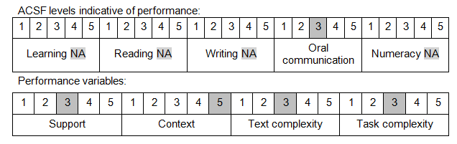

Further information on ACSF and the foundation skills underpinning this unit can be found in the Foundation Skills Guide on the GSA website.

Unit Mapping Information
This unit supersedes and is equivalent to DEFTP001B Operate a vehicle in an environment of threat.

Links
Companion Volume implementation guides are found in VETNet - https://vetnet.gov.au/Pages/TrainingDocs.aspx?q=6bdbab1e-11ed-4bc9-9cba-9e1a55d4e4a9
Companion Volume implementation guides are found in VETNet - https://vetnet.gov.au/Pages/TrainingDocs.aspx?q=6bdbab1e-11ed-4bc9-9cba-9e1a55d4e4a9
Companion Volume implementation guides are found in VETNet - https://vetnet.gov.au/Pages/TrainingDocs.aspx?q=6bdbab1e-11ed-4bc9-9cba-9e1a55d4e4a9

