DEFSUR009 Trap and kill animals in a survival situation
Release: 1

DEFSUR009 Trap and kill animals in a survival situation

Modification History
Release | Comments
1 | This unit was released in DEF Defence Training Package release 1.0 and meets the Standards for Training Packages.  This unit supersedes and is equivalent to DEFSU009B Trap and kill animals in a survival situation.  - Unit code updated  - Content and formatting updated to comply with new standards  - All PC transitioned from passive to active voice  - PC 1.1, 2.6, 2.8 and 2.9 revised  - PC 2.1, 2.2 and 2.3 merged

Application
This unit describes the skills required to trap and kill animals in a survival situation. The individual is not expected to be an expert trapper or butcher, but rather to have sufficient skills and knowledge to catch animals using trapping techniques, and to kill and butcher the animal including inspecting for signs of disease.
This unit was developed for Defence personnel but may be relevant to others.
The skills and knowledge described in this unit must be applied within the legislative, regulatory and policy environment in which they are carried out. Organisational policies and procedures must be consulted and adhered to.
Those undertaking this unit would act autonomously, while performing concrete, tasks in a broad range of contexts which may be highly unpredictable.
No licensing, legislative or certification requirements apply to unit at the time of publication.

Competency Field
Survival

Elements and Performance Criteria
ELEMENTS | PERFORMANCE CRITERIA
Elements describe the essential outcomes | Performance criteria describe the performance needed to demonstrate achievement of the element. Where bold italicised text is used, further information is detailed in the range of conditions section.
1. Trap animals | 1.1 Develop a capture plan including trap height, location and type, as well as means of attraction, by identifying animal signs and by interpreting drinking, eating, foraging, mating, and sleeping habits.  1.2 Acquire bait attractive to the targeted animal.  1.3 Create traps from natural resources.  1.4 Deploy and camouflage traps on likely animal travel routes.  1.5 Check traps regularly for captured animals.
2. Slaughter animals | 2.1 Conduct slaughter humanely to cause minimum stress for the animal.  2.2 Skin or pluck carcass.  2.3 Hang carcass for butchering.  2.4 Butcher carcass by cutting edible portions (dressing) of meat and by removing internal organs.  2.5 Inspect offal for signs of disease.  2.6 Protect meat from the elements including flyblow, scavenging animals and the sun.  2.7 Maintain hygiene of the slaughterer.  2.8 Maintain hygiene of the carcass.

Foundation Skills
The foundation skills demands of this unit have been mapped for alignment with the Australian Core Skills Framework (ACSF). The following tables outline the performance levels indicated for successful attainment of the unit.
ACSF levels indicative of performance:
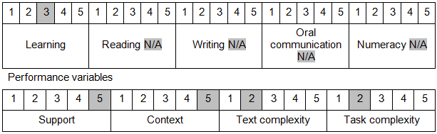

Further information on ACSF and the foundation skills underpinning this unit can be found in the Foundation Skills Guide on the GSA website.

Unit Mapping Information
This unit supersedes and is equivalent to DEFSU009B Trap and kill animals in a survival situation.

Links
Companion Volume implementation guides are found in VETNet - https://vetnet.gov.au/Pages/TrainingDocs.aspx?q=6bdbab1e-11ed-4bc9-9cba-9e1a55d4e4a9
Companion Volume implementation guides are found in VETNet - https://vetnet.gov.au/Pages/TrainingDocs.aspx?q=6bdbab1e-11ed-4bc9-9cba-9e1a55d4e4a9
Companion Volume implementation guides are found in VETNet - https://vetnet.gov.au/Pages/TrainingDocs.aspx?q=6bdbab1e-11ed-4bc9-9cba-9e1a55d4e4a9

