DEFSUR008 Produce fire using improvised means in a survival situation
Release: 1

DEFSUR008 Produce fire using improvised means in a survival situation

Modification History
Release | Comments
1 | This unit was released in DEF Defence Training Package release 1.0 and meets the Standards for Training Packages.  This unit supersedes and is equivalent to DEFSU008B Produce fire using improvised means in a survival situation.  - Unit code updated  - Content and formatting updated to comply with new standards  - All PC transitioned from passive to active voice  - PC 2.1 revised

Application
This unit describes the skills required to initiate and maintain fire in a survival situation. Fire is one of the most critical survival resources because of the range of applications, from preventing hypothermia and sterilising water to initiating rescue signals. The individual is expected to produce fire from improvised means (which may include traditional means if there are no alternatives).
This unit was developed for Defence personnel but may be relevant to others.
The skills and knowledge described in this unit must be applied within the legislative, regulatory and policy environment in which they are carried out. Organisational policies and procedures must be consulted and adhered to.
Those undertaking this unit would act autonomously, while performing concrete tasks, in a broad range of contexts which may be highly unpredictable.
No licensing, legislative or certification requirements apply to unit at the time of publication.

Competency Field
Survival

Elements and Performance Criteria
ELEMENTS | PERFORMANCE CRITERIA
Elements describe the essential outcomes | Performance criteria describe the performance needed to demonstrate achievement of the element. Where bold italicised text is used, further information is detailed in the range of conditions section.
1. Prepare for fire starting | 1.1 Collect, dry and protect tinder.  1.2 Collect, prepare and store kindling.  1.3 Collect, prepare and store fuel (branches, logs) in a dry location.
2. Start and maintain fire | 2.1 Site and prepare a fire-safe area, minimising threat to survivor effects and equipment and preventing escape of the fire into surrounding vegetation.  2.2 Use improvised means to start fire.  2.3 Prevent fire from extinguishing in all weather conditions.

Foundation Skills
The foundation skills demands of this unit have been mapped for alignment with the Australian Core Skills Framework (ACSF). The following tables outline the performance levels indicated for successful attainment of the unit.
ACSF levels indicative of performance:
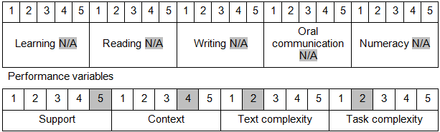

Further information on ACSF and the foundation skills underpinning this unit can be found in the Foundation Skills Guide on the GSA website.

Unit Mapping Information
This unit supersedes and is equivalent to DEFSU008B Produce fire using improvised means in a survival situation.

Links
Companion Volume implementation guides are found in VETNet - https://vetnet.gov.au/Pages/TrainingDocs.aspx?q=6bdbab1e-11ed-4bc9-9cba-9e1a55d4e4a9
Companion Volume implementation guides are found in VETNet - https://vetnet.gov.au/Pages/TrainingDocs.aspx?q=6bdbab1e-11ed-4bc9-9cba-9e1a55d4e4a9
Companion Volume implementation guides are found in VETNet - https://vetnet.gov.au/Pages/TrainingDocs.aspx?q=6bdbab1e-11ed-4bc9-9cba-9e1a55d4e4a9

