DEFSUR007 Preserve and cook foodstuffs in a survival situation
Release: 1

DEFSUR007 Preserve and cook foodstuffs in a survival situation

Modification History
Release | Comments
1 | This unit was released in DEF Defence Training Package release 1.0 and meets the Standards for Training Packages.  This unit supersedes and is equivalent to DEFSU007B Preserve and cook foodstuffs in a survival situation.  - Unit code updated  - Content and formatting updated to comply with new standards  - All PC transitioned from passive to active voice

Application
This unit describes the skills required to preserve and cook foodstuffs in a survival situation. This unit also covers the prudent management of food assets and implementing personal measures to minimise energy expenditure to enhance survival chances. The individual is not expected to be a camp chef, but rather to possess sufficient skills and knowledge to obtain, where possible, a measure of sustenance from the environment through cooking, or preserving for longer-term consumption.
This unit was developed for Defence personnel but may be relevant to others.
The skills and knowledge described in this unit must be applied within the legislative, regulatory and policy environment in which they are carried out. Organisational policies and procedures must be consulted and adhered to.
Those undertaking this unit would act autonomously, while performing concrete tasks, in a broad range of contexts which may be highly unpredictable.
No licensing, legislative or certification requirements apply to unit at the time of publication.

Competency Field
Survival

Elements and Performance Criteria
ELEMENTS | PERFORMANCE CRITERIA
Elements describe the essential outcomes | Performance criteria describe the performance needed to demonstrate achievement of the element. Where bold italicised text is used, further information is detailed in the range of conditions section.
1. Preserve and cook flora and fauna | 1.1 Apply testing procedures to unknown flora to identify their fitness for consumption.  1.2 Remove harmful components of animal and vegetable foodstuffs.  1.3 Use improvised cooking techniques to prepare animal and vegetable foodstuffs for consumption to reduce the chances of acquiring parasites and germs.  1.4 Use improvised preserving techniques to preserve animal and vegetable foodstuffs to allow long-term storage without any harmful organisms spoiling the foodstuff.
2. Manage food resources | 2.1 Implement energy management techniques to minimise unnecessary wastage.  2.2 Ration foodstuffs in accordance with survival requirements.

Foundation Skills
The foundation skills demands of this unit have been mapped for alignment with the Australian Core Skills Framework (ACSF). The following tables outline the performance levels indicated for successful attainment of the unit.
ACSF levels indicative of performance:
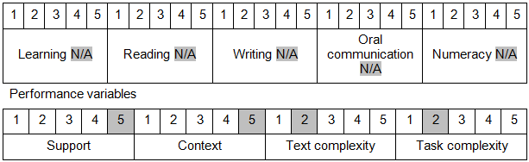

Further information on ACSF and the foundation skills underpinning this unit can be found in the Foundation Skills Guide on the GSA website.

Unit Mapping Information
This unit supersedes and is equivalent to DEFSU007B Preserve and cook foodstuffs in a survival situation.

Links
Companion Volume implementation guides are found in VETNet - https://vetnet.gov.au/Pages/TrainingDocs.aspx?q=6bdbab1e-11ed-4bc9-9cba-9e1a55d4e4a9
Companion Volume implementation guides are found in VETNet - https://vetnet.gov.au/Pages/TrainingDocs.aspx?q=6bdbab1e-11ed-4bc9-9cba-9e1a55d4e4a9
Companion Volume implementation guides are found in VETNet - https://vetnet.gov.au/Pages/TrainingDocs.aspx?q=6bdbab1e-11ed-4bc9-9cba-9e1a55d4e4a9

