DEFSUR004 Erect a survival shelter using natural resources in a survival situation
Release: 1

DEFSUR004 Erect a survival shelter using natural resources in a survival situation

Modification History
Release | Comments
1 | This unit was released in DEF Defence Training Package release 1.0 and meets the Standards for Training Packages.  This unit supersedes and is equivalent to DEFSU004B Erect a survival shelter using natural resources in a survival situation.  - Unit code updated  - Content and formatting updated to comply with new standards  - All PC transitioned from passive to active voice  - PC 2.2 and 2.3 revised

Application
This unit describes the skills required to erect a survival shelter in a survival situation. The individual is not expected to be an expert in building construction, but rather to have the requisite skills and knowledge to identify the elemental threats to his/her survival such as sun, wind and rain, and to establish a survival shelter to provide the necessary protection. The shelter may take advantage of established natural features or may demand stand-alone construction from natural resources. This unit assumes that manufactured resources are not available.
This unit was developed for Defence personnel but may be relevant to others
The skills and knowledge described in this unit must be applied within the legislative, regulatory and policy environment in which they are carried out. Organisational policies and procedures must be consulted and adhered to.
Those undertaking this unit would act autonomously, while performing concrete tasks, in a broad range of contexts which may be highly unpredictable.
No licensing, legislative or certification requirements apply to unit at the time of publication.

Competency Field
Survival

Elements and Performance Criteria
ELEMENTS | PERFORMANCE CRITERIA
Elements describe the essential outcomes | Performance criteria describe the performance needed to demonstrate achievement of the element. Where bold italicised text is used, further information is detailed in the range of conditions section.
1. Prepare resources for erection of survival shelter | 1.1 Identify potential threat to personal survival posed by the elements and use natural features to provide immediate protection.  1.2 Optimise survival shelter’s siting for protection from the elements and to minimise hazards to the survivalist, taking advantage, where possible, of existing natural resources.  1.3 Collect resources to construct survival shelter to maximise shelter strength and protection, while minimising physical effort.
2. Construct survival shelter | 2.1 Construct traditional two-ply string for use in binding and securing.  2.2 Establish survival shelter’s framework, taking maximum advantage of the strength of natural junction points such as forks, by using and binding with improvised cordage.  2.3 Protect survival shelter from wind and rain, using shingling (bark sections and large leaves) and thatching (bound grass and bundled grass) for roofing and siding.

Foundation Skills
The foundation skills demands of this unit have been mapped for alignment with the Australian Core Skills Framework (ACSF). The following tables outline the performance levels indicated for successful attainment of the unit.
ACSF levels indicative of performance:
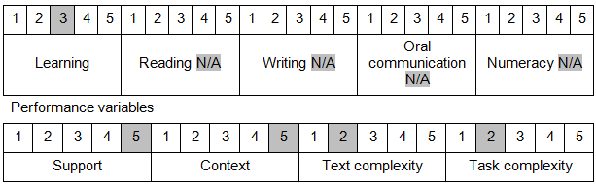

Further information on ACSF and the foundation skills underpinning this unit can be found in the Foundation Skills Guide on the GSA website.

Unit Mapping Information
This unit supersedes and is equivalent to DEFSU004B Erect a survival shelter using natural resources in a survival situation.

Links
Companion Volume implementation guides are found in VETNet - https://vetnet.gov.au/Pages/TrainingDocs.aspx?q=6bdbab1e-11ed-4bc9-9cba-9e1a55d4e4a9
Companion Volume implementation guides are found in VETNet - https://vetnet.gov.au/Pages/TrainingDocs.aspx?q=6bdbab1e-11ed-4bc9-9cba-9e1a55d4e4a9
Companion Volume implementation guides are found in VETNet - https://vetnet.gov.au/Pages/TrainingDocs.aspx?q=6bdbab1e-11ed-4bc9-9cba-9e1a55d4e4a9

