DEFSEN008 Support the compilation of the tactical picture
Release: 1

DEFSEN008 Support the compilation of the tactical picture

Modification History
Release | Comments
1 | This unit was released in DEF Defence Training Package release 1.0 and meets the Standards for Training Packages.  This unit supersedes and is equivalent to DEFSO008A Support the compilation of the tactical picture.  - Unit code updated  - Content and formatting updated to comply with new standards  - All PC transitioned from passive to active voice  - Element 2 reworded  - PC 1.3 and 1.4 revised

Application
This unit covers the competency required to provide support to the compilation of a tactical picture. It includes operating a sensor display to display and allow interpretation of tactical information. It also includes monitoring the sensor display for irregularities and taking steps to return the sensor display to optimal performance.
This unit was developed for Sensor Operators working within Defence but is applicable to any individual in this field of work.
The skills and knowledge described in this unit must be applied within the legislative, regulatory and policy environment in which they are carried out. Organisational policies and procedures must be consulted and adhered to.
Those undertaking this unit would work as part of a team, under supervision, while performing routine tasks in a broad range of contexts and environments. They use discretion and judgement and take responsibility for the quality of their output.
No licensing, legislative or certification requirements apply to unit at the time of publication.

Competency Field
Sensor Operations

Elements and Performance Criteria
ELEMENTS | PERFORMANCE CRITERIA
Elements describe the essential outcomes | Performance criteria describe the performance needed to demonstrate achievement of the element. Where bold italicised text is used, further information is detailed in the range of conditions section.
1. Detect and track contacts using sensors | 1.1 Detect contacts by monitoring sensor display.  1.2 Analyse sensor returns to recognise valid contacts.  1.3 Track contacts.  1.4 Alert shift supervisor and other sensor operators of the contact by transmitting initial contact report.  1.5 Monitor tracking of contacts to ensure the validity of the track.  1.6 Perform manual tracking of contacts in the event of loss of automatic tracking of critical contacts.
2. Recognise contact | 2.1 Classify contacts.  2.2 Assign identity of contacts to enable quick reference and identification by other sensor operators.  2.3 Transmit supplementary contact reports.  2.4 Recognise information from other sources and reclassify contact designated as ambiguous as required.

Foundation Skills
The foundation skills demands of this unit have been mapped for alignment with the Australian Core Skills Framework (ACSF). The following tables outline the performance levels indicated for successful attainment of the unit.
ACSF levels indicative of performance:
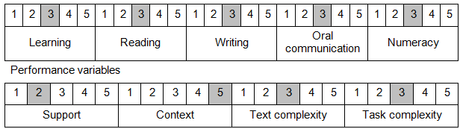

Further information on ACSF and the foundation skills underpinning this unit can be found in the Foundation Skills Guide on the GSA website.

Unit Mapping Information
This unit supersedes and is equivalent to DEFSO008A Support the compilation of the tactical picture.

Links
Companion Volume implementation guides are found in VETNet - https://vetnet.gov.au/Pages/TrainingDocs.aspx?q=6bdbab1e-11ed-4bc9-9cba-9e1a55d4e4a9
Companion Volume implementation guides are found in VETNet - https://vetnet.gov.au/Pages/TrainingDocs.aspx?q=6bdbab1e-11ed-4bc9-9cba-9e1a55d4e4a9
Companion Volume implementation guides are found in VETNet - https://vetnet.gov.au/Pages/TrainingDocs.aspx?q=6bdbab1e-11ed-4bc9-9cba-9e1a55d4e4a9

