DEFSEN005 Operate decoy systems
Release: 1

DEFSEN005 Operate decoy systems

Modification History
Release | Comments
1 | This unit was released in DEF Defence Training Package release 1.0 and meets the Standards for Training Packages.  This unit supersedes and is equivalent to DEFSO005C Operate decoy systems.  - Unit code updated  - Content and formatting updated to comply with new standards  - All PC transitioned from passive to active voice  - PC 2.1 and 2.2 merged and PC 3.2 and 3.3 merged

Application
This unit describes the skills required to operate decoy systems as part of a team and under supervision. It includes the requirement to prepare, optimise and deploy the decoy systems. This activity could continue for a prolonged period, requiring the operator to hand over effectively to another operator.
This unit was developed for Sensor Operators working within Defence but is applicable to any individual in this field of work.
The skills and knowledge described in this unit must be applied within the legislative, regulatory and policy environment in which they are carried out. Organisational policies and procedures must be consulted and adhered to.
Those undertaking this unit would work as part of a team, under supervision, while performing routine tasks in a broad range of contexts and environments. They use discretion and judgement and take responsibility for the quality of their output.
No licensing, legislative or certification requirements apply to unit at the time of publication.

Competency Field
Sensor Operations

Elements and Performance Criteria
ELEMENTS | PERFORMANCE CRITERIA
Elements describe the essential outcomes | Performance criteria describe the performance needed to demonstrate achievement of the element. Where bold italicised text is used, further information is detailed in the range of conditions section.
1. Prepare decoy systems | 1.1 Establish internal and external communications.  1.2 Confirm serviceability of decoy system and recognise and report any faults to supervisor.  1.3 Determine outside environmental conditions.  1.4 Optimise decoy system for appropriate threat.
2. Operate decoy systems | 2.1 Receive instructions from supervisor or relevant authority and deploy decoy as directed.  2.2 Reload decoy system.  2.3 Report any problems or issues beyond own capability to rectify to supervisor.
3. Finalise operations | 3.1 Transfer decoy system status to new operator as required or cease operation as directed by supervisor.  3.2 Secure system and secure and stow documentation.

Foundation Skills
The foundation skills demands of this unit have been mapped for alignment with the Australian Core Skills Framework (ACSF). The following tables outline the performance levels indicated for successful attainment of the unit.
ACSF levels indicative of performance:
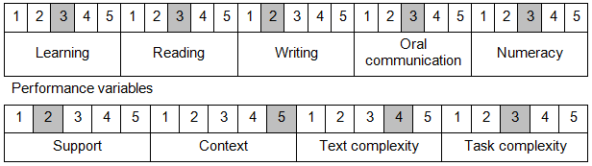

Further information on ACSF and the foundation skills underpinning this unit can be found in the Foundation Skills Guide on the GSA website.

Unit Mapping Information
This unit supersedes and is equivalent to DEFSO005C Operate decoy systems.

Links
Companion Volume implementation guides are found in VETNet - https://vetnet.gov.au/Pages/TrainingDocs.aspx?q=6bdbab1e-11ed-4bc9-9cba-9e1a55d4e4a9
Companion Volume implementation guides are found in VETNet - https://vetnet.gov.au/Pages/TrainingDocs.aspx?q=6bdbab1e-11ed-4bc9-9cba-9e1a55d4e4a9
Companion Volume implementation guides are found in VETNet - https://vetnet.gov.au/Pages/TrainingDocs.aspx?q=6bdbab1e-11ed-4bc9-9cba-9e1a55d4e4a9

