DEFSEN002 Operate a sonar system
Release: 1

DEFSEN002 Operate a sonar system

Modification History
Release | Comments
1 | This unit was released in DEF Defence Training Package release 1.0 and meets the Standards for Training Packages.  This unit supersedes and is equivalent to DEFSO002C Operate a sonar system.  - Unit code updated  - Content and formatting updated to comply with new standards  - All PC transitioned from passive to active voice  - PC 1.1 removed  - PC 1.4, 1.5 revised  - PC 2.1 and 2.2 merged

Application
This unit describes the skills required to operate a sonar system. It includes the requirement to configure the system, build and maintain the continuous collection, and collate and analyse information to track existing contacts or identify new contacts. This activity could continue for a prolonged period, requiring the operator to hand over effectively to another operator.
This unit was developed for Sensor Operators working within Defence but is applicable to any individual in this field of work.
The skills and knowledge described in this unit must be applied within the legislative, regulatory and policy environment in which they are carried out. Organisational policies and procedures must be consulted and adhered to.
Those undertaking this unit would work as part of a team, under supervision, while performing routine tasks in a broad range of contexts and environments. They use discretion and judgement and take responsibility for the quality of their output.
No licensing, legislative or certification requirements apply to unit at the time of publication.

Competency Field
Sensor Operations

Elements and Performance Criteria
ELEMENTS | PERFORMANCE CRITERIA
Elements describe the essential outcomes | Performance criteria describe the performance needed to demonstrate achievement of the element. Where bold italicised text is used, further information is detailed in the range of conditions section.
1. Configure sonar system | 1.1 Confirm sonar system serviceability (daily system operability tests [DSOTs]) and report any faults to supervisor.  1.2 Optimise sonar display for operator use.  1.3 Optimise system in line with the environmental conditions.  1.4 Use environmental tools such as expendable bathythermograph or tactical environment support system.
2. Compile and maintain a sonar picture | 2.1 Identify, track and discriminate between sonar contacts by collecting, collating and analysing information.  2.2 Collect acoustic information from other sensors/sources.  2.3 Report, display and disseminate sonar contact details to stakeholders.  2.4 Respond to threats.  2.5 Report problems beyond own capability to supervisor.
3. Finalise operations | 3.1 Cease or transfer sonar system operation to new operator as directed by supervisor.  3.2 Secure and stow system.  3.3 Secure and stow documentation.  3.4 Report to supervisor on completion.

Foundation Skills
The foundation skills demands of this unit have been mapped for alignment with the Australian Core Skills Framework (ACSF). The following tables outline the performance levels indicated for successful attainment of the unit.
ACSF levels indicative of performance:
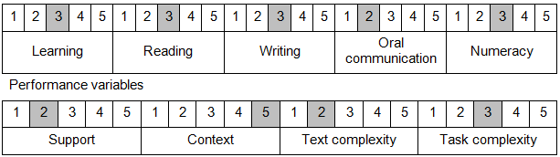

Further information on ACSF and the foundation skills underpinning this unit can be found in the Foundation Skills Guide on the GSA website.

Unit Mapping Information
This unit supersedes and is equivalent to DEFSO002C Operate a sonar system.

Links
Companion Volume implementation guides are found in VETNet - https://vetnet.gov.au/Pages/TrainingDocs.aspx?q=6bdbab1e-11ed-4bc9-9cba-9e1a55d4e4a9
Companion Volume implementation guides are found in VETNet - https://vetnet.gov.au/Pages/TrainingDocs.aspx?q=6bdbab1e-11ed-4bc9-9cba-9e1a55d4e4a9
Companion Volume implementation guides are found in VETNet - https://vetnet.gov.au/Pages/TrainingDocs.aspx?q=6bdbab1e-11ed-4bc9-9cba-9e1a55d4e4a9

