DEFSEA009 Operate a visual target designation system
Release: 1

DEFSEA009 Operate a visual target designation system

Modification History
Release | Comments
1 | This unit was released in DEF Defence Training Package release 1.0 and meets the Standards for Training Packages.  This unit supersedes and is equivalent to DEFBM009A Operate a visual target designator system.  - Unit code updated  - Content and formatting updated to comply with new standards  - All PC transitioned from passive to active voice  - PC 1.1 removed

Application
This unit describes the skills required to operate a visual target designation system. It includes preparing the equipment for operation, acquiring air and surface targets, interpreting position data and communicating information for use in targeting.
This unit typically applies to a Naval Defence environment and was developed for boatswain’s mates but is applicable to any individual in this field of work.
The skills and knowledge described in this unit must be applied within the legislative, regulatory and policy environment in which they are carried out. Organisational policies and procedures must be consulted and adhered to.
Those undertaking this unit would generally perform routine tasks as part of a team and under indirect supervision. They would need to be prepared for a wide of range of contexts that could be unfamiliar and highly unpredictable.
No licensing, legislative or certification requirements apply to unit at the time of publication.

Competency Field
Maritime Operations

Elements and Performance Criteria
ELEMENTS | PERFORMANCE CRITERIA
Elements describe the essential outcomes | Performance criteria describe the performance needed to demonstrate achievement of the element. Where bold italicised text is used, further information is detailed in the range of conditions section.
1. Prepare visual target designation system | 1.1 Select and wear personal protective equipment.  1.2 Inspect and test target designation system components and report faults.
2. Operate visual target designation equipment | 2.1 Collect task requirements and confirm with supervisor.  2.2 Maintain communication with operations room throughout operations.  2.3 Conduct area search.  2.4 Report collected target information.  2.5 Identify targets and confirm with supervisor.  2.6 Sight and track targets using the system as directed.  2.7 Fire remote weapon using the system as ordered by supervisor.  2.8 Respond to emergencies/incidents.
3. Finalise operations | 3.1 Cease or transfer system operation to new operator as directed by supervisor.  3.2 Clean and secure system.  3.3 Report to supervisor on completion.

Foundation Skills
The foundation skills demands of this unit have been mapped for alignment with the Australian Core Skills Framework (ACSF). The following tables outline the performance levels indicated for successful attainment of the unit.
ACSF levels indicative of performance:
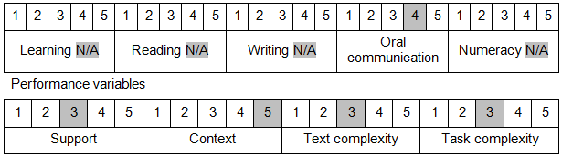

Further information on ACSF and the foundation skills underpinning this unit can be found in the Foundation Skills Guide on the GSA website.

Unit Mapping Information
This unit supersedes and is equivalent to DEFBM009A Operate a visual target designator system.

Links
Companion Volume implementation guides are found in VETNet - https://vetnet.gov.au/Pages/TrainingDocs.aspx?q=6bdbab1e-11ed-4bc9-9cba-9e1a55d4e4a9
Companion Volume implementation guides are found in VETNet - https://vetnet.gov.au/Pages/TrainingDocs.aspx?q=6bdbab1e-11ed-4bc9-9cba-9e1a55d4e4a9
Companion Volume implementation guides are found in VETNet - https://vetnet.gov.au/Pages/TrainingDocs.aspx?q=6bdbab1e-11ed-4bc9-9cba-9e1a55d4e4a9

