DEFSEA008 Operate a chaff firing system
Release: 1

DEFSEA008 Operate a chaff firing system

Modification History
Release | Comments
1 | This unit was released in DEF Defence Training Package release 1.0 and meets the Standards for Training Packages.  This unit supersedes and is equivalent to DEFBM008A Operate a chaff firing system.  - Unit code updated  - Content and formatting updated to comply with new standards  - All PC transitioned from passive to active voice  - PC 1.2 removed

Application
This unit describes the skills required to operate a chaff firing system. It includes handling ammunition, and loading and unloading a chaff firing system. It also involves strict compliance with safety precautions and responding to commands from a supervisor.
This unit typically applies to a Naval Defence environment and was developed for boatswain’s mates but is applicable to any individual in this field of work.
The skills and knowledge described in this unit must be applied within the legislative, regulatory and policy environment in which they are carried out. Organisational policies and procedures must be consulted and adhered to.
Those undertaking this unit would generally perform routine tasks as part of a team and under indirect supervision. They would need to be prepared for a wide of range of contexts that could be unfamiliar and highly unpredictable.
No licensing, legislative or certification requirements apply to unit at the time of publication.

Competency Field
Maritime Operations

Elements and Performance Criteria
ELEMENTS | PERFORMANCE CRITERIA
Elements describe the essential outcomes | Performance criteria describe the performance needed to demonstrate achievement of the element. Where bold italicised text is used, further information is detailed in the range of conditions section.
1. Load and unload chaff firing system | 1.1 Collect task requirements and confirm with supervisor.  1.2 Select and wear appropriate personal protective equipment.  1.3 Maintain communication with team members throughout chaff firing operations.  1.4 Conduct pre-firing checks under supervisor directions.  1.5 Identify and select ammunition.  1.6 Load and unload chaff firing system under supervisor directions.  1.7 Recognise and act on pre-firing warnings.  1.8 Respond to emergencies/incidents.
2. Secure chaff firing system | 2.1 Check chaff firing system for serviceability and safety under supervisor directions.  2.2 Report faults or damage.  2.3 Clean, inspect, carry and secure ammunition.

Foundation Skills
The foundation skills demands of this unit have been mapped for alignment with the Australian Core Skills Framework (ACSF). The following tables outline the performance levels indicated for successful attainment of the unit.
ACSF levels indicative of performance:
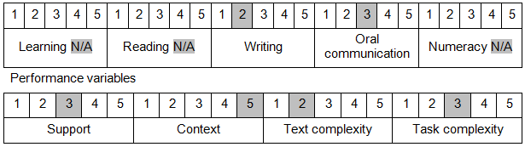

Further information on ACSF and the foundation skills underpinning this unit can be found in the Foundation Skills Guide on the GSA website.

Unit Mapping Information
This unit supersedes and is equivalent to DEFBM008A Operate a chaff firing system.

Links
Companion Volume implementation guides are found in VETNet - https://vetnet.gov.au/Pages/TrainingDocs.aspx?q=6bdbab1e-11ed-4bc9-9cba-9e1a55d4e4a9
Companion Volume implementation guides are found in VETNet - https://vetnet.gov.au/Pages/TrainingDocs.aspx?q=6bdbab1e-11ed-4bc9-9cba-9e1a55d4e4a9
Companion Volume implementation guides are found in VETNet - https://vetnet.gov.au/Pages/TrainingDocs.aspx?q=6bdbab1e-11ed-4bc9-9cba-9e1a55d4e4a9

