DEFRNG011 Site range complexes
Release: 1

DEFRNG011 Site range complexes

Modification History
Release | Comments
1 | This unit was released in DEF Defence Training Package release 1.0 and meets the Standards for Training Packages.  This unit supersedes and is equivalent to DEFRM211B Site range complexes.  - Unit code updated  - Content and formatting updated to comply with new standards  - All PC transitioned from passive to active voice

Application
This unit describes the skills required to site range complexes as a member of a Range Siting Board. It includes the processes of siting individual ranges or a group of ranges as part of a range complex ensuring the efficient utilisation of land and the safety requirements related to the use of weapons and ammunition.
This unit was developed for Defence personnel who work in range management and range control but may be relevant to others who work in this field.
The skills and knowledge described in this unit must be applied within the legislative, regulatory and policy environment in which they are carried out. Organisational policies and procedures must be consulted and adhered to.
Those undertaking this unit would work independently or as part of a team under indirect supervision, while performing complex tasks, in a range of familiar contexts. They would use discretion and judgement and take responsibility for the quality of their outputs.
No licensing, legislative or certification requirements apply to unit at the time of publication.

Competency Field
Range

Elements and Performance Criteria
ELEMENTS | PERFORMANCE CRITERIA
Elements describe the essential outcomes | Performance criteria describe the performance needed to demonstrate achievement of the element. Where bold italicised text is used, further information is detailed in the range of conditions section.
1. Prepare to site range complexes | 1.1 Confirm appointment to the Range Siting Board.  1.2 Identify and research range user requirement.  1.3 Identify and acquire resources required for the Range Siting Board.  1.4 Establish and maintain contact with other board members.
2. Site range complexes | 2.1 Develop options to meet the user requirement in accordance with Range Siting Board requirements.  2.2 Undertake reconnaissance of proposed and alternate range site in accordance with Range Siting Board requirements.  2.3 Assess proposed and alternate sites.  2.4 Provide technical advice to guide Range Siting Board members in their considerations.  2.5 Select the best option in consultation with Range Siting Board members.
3. Finalise Range Siting Board reports | 3.1 Produce range development and works proposals in accordance with the Range Siting Board terms of reference.  3.2 Adjust and finalise proposed range templates and traces.  3.3 Contribute to final report in accordance with Range Siting Board requirements.  3.4 Finalise range inspector’s report and submit to Range Siting Board.

Foundation Skills
The foundation skills demands of this unit have been mapped for alignment with the Australian Core Skills Framework (ACSF). The following tables outline the performance levels indicated for successful attainment of the unit.
ACSF levels indicative of performance:
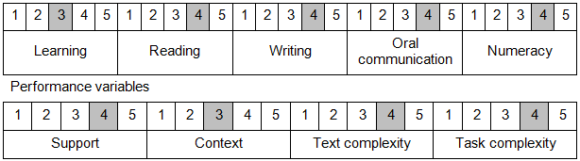

Further information on ACSF and the foundation skills underpinning this unit can be found in the Foundation Skills Guide on the GSA website.

Unit Mapping Information
This unit supersedes and is equivalent to DEFRM211B Site range complexes.

Links
Companion Volume implementation guides are found in VETNet - https://vetnet.gov.au/Pages/TrainingDocs.aspx?q=6bdbab1e-11ed-4bc9-9cba-9e1a55d4e4a9
Companion Volume implementation guides are found in VETNet - https://vetnet.gov.au/Pages/TrainingDocs.aspx?q=6bdbab1e-11ed-4bc9-9cba-9e1a55d4e4a9
Companion Volume implementation guides are found in VETNet - https://vetnet.gov.au/Pages/TrainingDocs.aspx?q=6bdbab1e-11ed-4bc9-9cba-9e1a55d4e4a9

