DEFRNG006 Conduct range inspections
Release: 1

DEFRNG006 Conduct range inspections

Modification History
Release | Comments
1 | This unit was released in DEF Defence Training Package release 1.0 and meets the Standards for Training Packages.  This unit supersedes and is equivalent to DEFRM206B Conduct range inspections.  - Unit code updated  - Content and formatting updated to comply with new standards  - All PC transitioned from passive to active voice  - PC 2.1 revised  - PC 2.2 and 3.4 removed  - PC 2.3 and 3.4 merged

Application
This unit describes the skills required to plan, prepare, conduct and follow up on a range inspection. It includes the requirement to ensure the safety of the range and to identify those aspects that may inhibit or jeopardise the safety of the range including maintenance requirements.
This unit was developed for Defence personnel who work in range management and range control but may be relevant to others who work in this field.
The skills and knowledge described in this unit must be applied within the legislative, regulatory and policy environment in which they are carried out. Organisational policies and procedures must be consulted and adhered to.
Those undertaking this unit would work independently or as part of a team, under indirect supervision, while performing routine tasks, in a small range of familiar contexts. They would use discretion and judgement and take responsibility for the quality of their outputs.
No licensing, legislative or certification requirements apply to unit at the time of publication.

Competency Field
Range

Elements and Performance Criteria
ELEMENTS | PERFORMANCE CRITERIA
Elements describe the essential outcomes | Performance criteria describe the performance needed to demonstrate achievement of the element. Where bold italicised text is used, further information is detailed in the range of conditions section.
1. Prepare to conduct range inspection | 1.1 Establish and confirm statutory requirements relevant to the range and purpose of the inspection with relevant personnel.  1.2 Obtain clearances for training area and range access.  1.3 Identify and acquire resources required for inspection.  1.4 Conduct inspection of research on the range.  1.5 Establish detailed plans for the inspection.
2. Conduct range inspection | 2.1 Conduct range inspections.  2.2 Record observations and apply immediate action when appropriate.  2.3 Establish and maintain relationships with range staff.
3. Report on range inspection | 3.1 Complete post inspection reports and briefs.  3.2 Report safety issues related to equipment and infrastructure maintenance and/or works requirements and follow-up.  3.3 Certify the safety of the range in accordance with statutory requirements.  3.4 Maintain inspection records and databases.

Foundation Skills
The foundation skills demands of this unit have been mapped for alignment with the Australian Core Skills Framework (ACSF). The following tables outline the performance levels indicated for successful attainment of the unit.
ACSF levels indicative of performance:
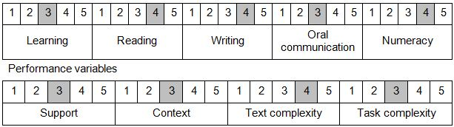

Further information on ACSF and the foundation skills underpinning this unit can be found in the Foundation Skills Guide on the GSA website.

Unit Mapping Information
This unit supersedes and is equivalent to DEFRM206B Conduct range inspections.

Links
Companion Volume implementation guides are found in VETNet - https://vetnet.gov.au/Pages/TrainingDocs.aspx?q=6bdbab1e-11ed-4bc9-9cba-9e1a55d4e4a9
Companion Volume implementation guides are found in VETNet - https://vetnet.gov.au/Pages/TrainingDocs.aspx?q=6bdbab1e-11ed-4bc9-9cba-9e1a55d4e4a9
Companion Volume implementation guides are found in VETNet - https://vetnet.gov.au/Pages/TrainingDocs.aspx?q=6bdbab1e-11ed-4bc9-9cba-9e1a55d4e4a9

