DEFMIL138 Supervise a section during defensive operations
Release: 1

DEFMIL138 Supervise a section during defensive operations

Modification History
Release | Comments
1 | This unit was released in DEF Defence Training Package release 1.0 and meets the Standards for Training Packages.  This unit supersedes and is equivalent to DEFCM133 Supervise a section during defensive operations.  - Unit code updated  - Content and formatting updated to comply with the new standards  - All PC transitioned from passive to active voice  - PC 1.6, 2.2, 2.6 and 2.7 removed  - PC 3.5 reworded

Application
This unit describes the skills required to command, lead and manage groups of up to twelve personnel during defensive operations. Defensive operations are characterised by extreme environmental conditions with high levels of risk of serious injury or death from hostile action. Supervision during defensive operations requires supervisors to be incisive in a fluid and demanding environment, to act independently, and to lead by example.
This unit applies to combat arms personnel involved in the conduct of defensive operations in a deployed operational environment.
The skills and knowledge described in this unit must be applied within the legislative, regulatory and policy environment in which they are carried out. Organisational policies and procedures must be consulted and adhered to.
Those undertaking this unit would typically work as part of a team under direct and/or indirect supervision, but also must be prepared to act independently. They use discretion and judgement, and take responsibility for the quality of their outputs They would perform routine tasks in a broad range of unpredictable contexts.
No licensing, legislative or certification requirements apply to unit at the time of publication.

Competency Field
Military skills

Elements and Performance Criteria
ELEMENTS | PERFORMANCE CRITERIA
Elements describe the essential outcomes | Performance criteria describe the performance needed to demonstrate achievement of the element. Where bold italicised text is used, further information is detailed in the range of conditions section.
1. Prepare and plan for defensive operations | 1.1 Confirm ability of subordinates to complete the task.  1.2 Action personnel administration.  1.3 Receive and clarify orders in accordance with the higher commander’s intent.  1.4 Determine and manage constraints and risks relevant to the task.  1.5 Assemble appropriate resources for the task and report any shortfalls that limit capability to the chain of command.  1.6 Base planning decisions on a logical process to solve operational problems.  1.7 Conduct battle procedures.
2. Conduct defensive operations | 2.1 Prepare and deliver orders.  2.2 Conduct liaison in accordance with operational requirements.  2.3 Coordinate support from outside agencies.  2.4 Provide technical advice to the chain of command or supported agencies.  2.5 Recognise and respond to unexpected situations that require a quick and decisive response.  2.6 Exercise command authority.  2.7 Lead subordinates by example.  2.8 Carry out mission and tasks in accordance with orders.  2.9 Maintain communication with the chain of command as required.
3. Finalise defensive operations | 3.1 Conduct debriefs.  3.2 Conduct post activity analysis and make recommendations.  3.3 Recondition, replace or return equipment, stores and ammunition.  3.4 Complete documentation.  3.5 Monitor soldiers’ health and wellbeing and take appropriate action.

Foundation Skills
The foundation skills demands of this unit have been mapped for alignment with the Australian Core Skills Framework (ACSF). The following tables outline the performance levels indicated for successful attainment of the unit.

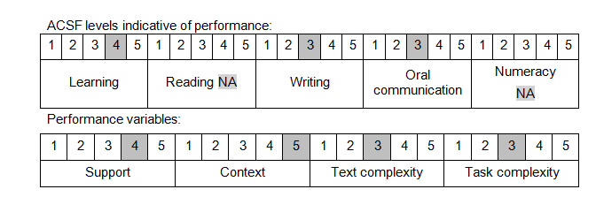

Further information on ACSF and the foundation skills underpinning this unit can be found in the Foundation Skills Guide on the GSA website.

Unit Mapping Information
This unit supersedes and is equivalent to DEFCM133 Supervise a section during defensive operations.

Links
Companion Volume implementation guides are found in VETNet - https://vetnet.gov.au/Pages/TrainingDocs.aspx?q=6bdbab1e-11ed-4bc9-9cba-9e1a55d4e4a9
Companion Volume implementation guides are found in VETNet - https://vetnet.gov.au/Pages/TrainingDocs.aspx?q=6bdbab1e-11ed-4bc9-9cba-9e1a55d4e4a9
Companion Volume implementation guides are found in VETNet - https://vetnet.gov.au/Pages/TrainingDocs.aspx?q=6bdbab1e-11ed-4bc9-9cba-9e1a55d4e4a9

