DEFMIL136 Supervise the operation of direct fire support weapons
Release: 1

DEFMIL136 Supervise the operation of direct fire support weapons

Modification History
Release | Comments
1 | This unit was released in DEF Defence Training Package release 1.0 and meets the Standards for Training Packages.  This unit supersedes and is equivalent to DEFCA433 Supervise the operation of direct fire support weapons.  - Unit code updated  - Content and formatting updated to comply with the new standards  - All PC transitioned from passive to active voice  - PC 1.4 and 3.3 removed

Application
This unit describes the skills required to supervise and control all aspects of the operation of direct fire support weapons.
This unit applies to combat arms personnel who are required to supervise and control all aspects of direct fire support weapons in a deployed operational environment.
The skills and knowledge described in this unit must be applied within the legislative, regulatory and policy environment in which they are carried out. Organisational policies and procedures must be consulted and adhered to.
Those undertaking this unit would lead a team under indirect supervision. They use discretion and judgement, and take responsibility for the quality of their outputs. They would perform routine tasks in a broad range of unpredictable contexts.
No licensing, legislative or certification requirements apply to unit at the time of publication.

Competency Field
Military skills

Elements and Performance Criteria
ELEMENTS | PERFORMANCE CRITERIA
Elements describe the essential outcomes | Performance criteria describe the performance needed to demonstrate achievement of the element. Where bold italicised text is used, further information is detailed in the range of conditions section.
1. Prepare and deploy direct fire support weapons | 1.1 Determine and organise resources required.  1.2 Report identified problems/shortfalls to immediate supervisor.  1.3 Deploy direct fire support weapons and establish and supervise the command post.
2. Engage targets with direct fire support weapons | 2.1 Confirm accuracy of all firing data.  2.2 Check lay of all weapons are correct before firing.  2.3 Give appropriate firing orders to the direct fire support weapon operators.  2.4 Select appropriate ammunition.  2.5 Direct and control direct fire support weapons operations.
3. Maintain direct fire support weapons | 3.1 Supervise operator maintenance activities.  3.2 Rectify reported defects within limits of authority or report to supervisor.

Foundation Skills
The foundation skills demands of this unit have been mapped for alignment with the Australian Core Skills Framework (ACSF). The following tables outline the performance levels indicated for successful attainment of the unit.

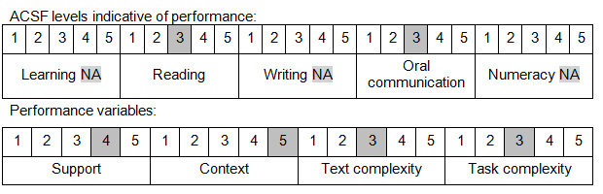

Further information on ACSF and the foundation skills underpinning this unit can be found in the Foundation Skills Guide on the GSA website.

Unit Mapping Information
This unit supersedes and is equivalent to DEFCA433 Supervise the operation of direct fire support weapons

Links
Companion Volume implementation guides are found in VETNet - https://vetnet.gov.au/Pages/TrainingDocs.aspx?q=6bdbab1e-11ed-4bc9-9cba-9e1a55d4e4a9
Companion Volume implementation guides are found in VETNet - https://vetnet.gov.au/Pages/TrainingDocs.aspx?q=6bdbab1e-11ed-4bc9-9cba-9e1a55d4e4a9
Companion Volume implementation guides are found in VETNet - https://vetnet.gov.au/Pages/TrainingDocs.aspx?q=6bdbab1e-11ed-4bc9-9cba-9e1a55d4e4a9

