DEFMIL134 Undertake sniper tasks
Release: 1

DEFMIL134 Undertake sniper tasks

Modification History
Release | Comments
1 | This unit was released in DEF Defence Training Package release 1.0 and meets the Standards for Training Packages.  This unit supersedes and is equivalent to DEFCA431 Undertake sniper tasks.  - Unit code updated  - Content and formatting updated to comply with the new standards  - All PC transitioned from passive to active voice  - PC 1.2 removed

Application
This unit describes the skills required to operate as a two man team during the conduct of sniper tasks in the Defence Force. Sniper operations require soldiers to operate in close proximity to the enemy in order to hit targets with rifle fire and gather information to inform their commanders. The sniper must be thoroughly familiar with characteristics and capabilities of the weapon and competent in the application of fire in an operational environment.
This unit applies to combat arms personnel required to operate as a two man team during the conduct of sniper tasks in a deployed operational environment.
The skills and knowledge described in this unit must be applied within the legislative, regulatory and policy environment in which they are carried out. Organisational policies and procedures must be consulted and adhered to.
Those undertaking this unit work independently and as part of a team under direct and/or indirect supervision, use discretion and judgement, and take responsibility for the quality of their outputs. They would perform specific tasks in a broad range of unpredictable contexts.
No licensing, legislative or certification requirements apply to unit at the time of publication.

Competency Field
Military skills

Elements and Performance Criteria
ELEMENTS | PERFORMANCE CRITERIA
Elements describe the essential outcomes | Performance criteria describe the performance needed to demonstrate achievement of the element. Where bold italicised text is used, further information is detailed in the range of conditions section.
1. Prepare for sniper tasks | 1.1 Interpret and clarify sniper orders where required.  1.2 Select and check appropriate equipment for serviceability and fit as directed and/or required by the operational environment.
2. Conduct a sniper patrol | 2.1 Complete movement ensuring that detection is avoided.  2.2 Achieve standard of operation and marksmanship.  2.3 Perform sniper patrol techniques.  2.4 Conduct drills and procedures.  2.5 Complete sniper tasks.  2.6 Conduct patrol debrief.

Foundation Skills
The foundation skills demands of this unit have been mapped for alignment with the Australian Core Skills Framework (ACSF). The following tables outline the performance levels indicated for successful attainment of the unit.

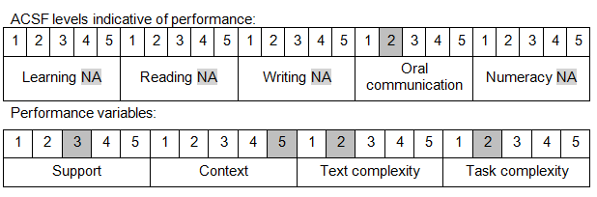

Further information on ACSF and the foundation skills underpinning this unit can be found in the Foundation Skills Guide on the GSA website.

Unit Mapping Information
This unit supersedes and is equivalent to DEFCA431 Undertake sniper tasks.

Links
Companion Volume implementation guides are found in VETNet - https://vetnet.gov.au/Pages/TrainingDocs.aspx?q=6bdbab1e-11ed-4bc9-9cba-9e1a55d4e4a9
Companion Volume implementation guides are found in VETNet - https://vetnet.gov.au/Pages/TrainingDocs.aspx?q=6bdbab1e-11ed-4bc9-9cba-9e1a55d4e4a9
Companion Volume implementation guides are found in VETNet - https://vetnet.gov.au/Pages/TrainingDocs.aspx?q=6bdbab1e-11ed-4bc9-9cba-9e1a55d4e4a9

