DEFMIL132 Undertake defensive actions
Release: 1

DEFMIL132 Undertake defensive actions

Modification History
Release | Comments
1 | This unit was released in DEF Defence Training Package release 1.0 and meets the Standards for Training Packages.  This unit supersedes and is equivalent to DEFCA429 Undertake defensive actions.  - Unit code updated  - Content and formatting updated to comply with the new standards  - All PC transitioned from passive to active voice

Application
This unit describes the skills required to operate as a team member during the conduct of defensive actions in the Australian Defence Force. For the purpose of this unit of competency, a team is defined as a group of up to approximately 30 personnel (for infantry this would be a section or platoon).
This unit was developed for those working in Defence as combat arms personnel required to deploy in an operational environment, but is applicable to any individual in this field of work.
The skills and knowledge described in this unit must be applied within the legislative, regulatory and policy environment in which they are carried out. Organisational policies and procedures must be consulted and adhered to.
Those undertaking this unit would work independently and as part of a team under direct and/or indirect supervision. They would use discretion and judgement, and take responsibility for the quality of their outputs. They would perform specific tasks in a broad range of unpredictable contexts.
No licensing, legislative, regulatory or certification requirements apply to this unit at the time of publication.

Competency Field
Military Skills

Elements and Performance Criteria
ELEMENTS | PERFORMANCE CRITERIA
Elements describe the essential outcomes | Performance criteria describe the performance needed to demonstrate achievement of the element. Where bold italicised text is used, further information is detailed in the range of conditions section.
1. Prepare for defensive actions | 1.1 Interpret defensive action orders and clarify where required.  1.2 Conduct battle procedure.  1.3 Select and fit personal and task specific equipment.
2. Conduct defensive actions | 2.1 Occupy defensive position.  2.2 Construct defences.  2.3 Conduct defensive routine.  2.4 Conduct drills and routines.  2.5 Withdraw from the defensive position.
3. Finalise defensive action activities | 3.1 Conduct post operation activities.  3.2 Conduct post action administration.

Foundation Skills
The foundation skills demands of this unit have been mapped for alignment with the Australian Core Skills Framework (ACSF). The following tables outline the performance levels indicated for successful attainment of the unit.

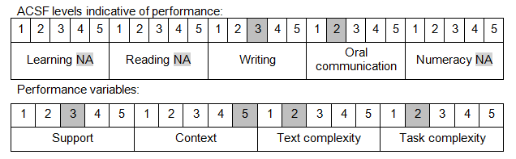

Further information on ACSF and the foundation skills underpinning this unit can be found in the Foundation Skills Guide on the GSA website.

Unit Mapping Information
This unit supersedes and is equivalent to DEFCA429 Undertake defensive actions.

Links
Companion Volume implementation guides are found in VETNet - https://vetnet.gov.au/Pages/TrainingDocs.aspx?q=6bdbab1e-11ed-4bc9-9cba-9e1a55d4e4a9
Companion Volume implementation guides are found in VETNet - https://vetnet.gov.au/Pages/TrainingDocs.aspx?q=6bdbab1e-11ed-4bc9-9cba-9e1a55d4e4a9
Companion Volume implementation guides are found in VETNet - https://vetnet.gov.au/Pages/TrainingDocs.aspx?q=6bdbab1e-11ed-4bc9-9cba-9e1a55d4e4a9

