DEFMIL129 Observe and direct machine gun fire
Release: 1

DEFMIL129 Observe and direct machine gun fire

Modification History
Release | Comments
1 | This unit was released in DEF Defence Training Package release 1.0 and meets the Standards for Training Packages.  This unit supersedes and is equivalent to DEFCA424B Observe and direct machine gun fire.  - Unit code updated  - Content and formatting updated to comply with the new standards  - All PC transitioned from passive to active voice

Application
This unit describes the skills required to observe and direct machine gun fire onto targets in accordance with standard procedures in the Defence Force.
This unit applies to those working as combat arms personnel required to observe and direct machine gun fire in a deployed operational environment.
The skills and knowledge described in this unit must be applied within the legislative, regulatory and policy environment in which they are carried out. Organisational policies and procedures must be consulted and adhered to.
Those undertaking this unit would work under the commander’s direction, and must also have authority to act independently. They will perform specific tasks in a broad range of unpredictable contexts.
No licensing, legislative or certification requirements apply to unit at the time of publication.

Competency Field
Military Skills

Elements and Performance Criteria
ELEMENTS | PERFORMANCE CRITERIA
Elements describe the essential outcomes | Performance criteria describe the performance needed to demonstrate achievement of the element. Where bold italicised text is used, further information is detailed in the range of conditions section.
1. Occupy and prepare a location | 1.1 Occupy appropriate vantage point and maintain concealment throughout operation.  1.2 Establish occupied position.  1.3 Establish and document reference points.  1.4 Monitor possible threats and prepare an appropriate plan of action.
2. Plan the engagement of firepower | 2.1 Use standard terminology so that clear communication with all stakeholders is maintained.  2.2 Establish target position.  2.3 Determine altitude of target from map.  2.4 Maintain communications with stakeholders throughout the operation and ensure personnel safety in the target area.  2.5 Describe target to stakeholders.  2.6 Determine type of engagement and convey instructions to the gun line.
3. Direct fire onto target | 3.1 Transmit planning information to the command post.  3.2 Transmit direction to fire to the gun line.  3.3 Complete target analysis after impact and if appropriate refer to supervisor.  3.4 Complete or terminate adjustments of fire.
4. Withdraw from an occupied location | 4.1 Recondition occupied position and remove all evidence of occupation.  4.2 Withdrawal from the occupied position.

Foundation Skills
The foundation skills demands of this unit have been mapped for alignment with the Australian Core Skills Framework (ACSF). The following tables outline the performance levels indicated for successful attainment of the unit.

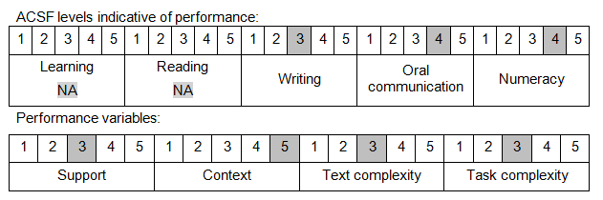

Further information on ACSF and the foundation skills underpinning this unit can be found in the Foundation Skills Guide on the GSA website.

Unit Mapping Information
This unit supersedes and is equivalent to DEFCA424B Observe and direct machine gun fire.

Links
Companion Volume implementation guides are found in VETNet - https://vetnet.gov.au/Pages/TrainingDocs.aspx?q=6bdbab1e-11ed-4bc9-9cba-9e1a55d4e4a9
Companion Volume implementation guides are found in VETNet - https://vetnet.gov.au/Pages/TrainingDocs.aspx?q=6bdbab1e-11ed-4bc9-9cba-9e1a55d4e4a9
Companion Volume implementation guides are found in VETNet - https://vetnet.gov.au/Pages/TrainingDocs.aspx?q=6bdbab1e-11ed-4bc9-9cba-9e1a55d4e4a9

