DEFMIL127 Conduct range practices
Release: 1

DEFMIL127 Conduct range practices

Modification History
Release | Comments
1 | This unit was released in DEF Defence Training Package release 1.0 and meets the Standards for Training Packages.  This unit supersedes and is equivalent to DEFCA422B Conduct range practices.  - Unit code updated  - Content and formatting updated to comply with the new standards  - All PC transitioned from passive to active voice  - PC 1.2 and 2.3 removed

Application
This unit describes the skills required to conduct weapons range practice, range practice may include the following types of ranges:
- standard 25 metre range
- 25 metre and 100 metre open ranges
- classification range
- static mechanical range
- MTR
- field firing ranges including small arms, high explosive, anti-armour and indirect fire weapons
- WTSS
This unit encompasses the safe and efficient planning and conducting of range practices as the Officer in Charge (OIC). Conducting, in this instance, also includes effective supervision of safety, and the preparation and finalisation of range practice using weapons and ammunition for which the OIC is qualified to operate.
This unit applies to Defence personnel required to perform the duties of OIC for the conduct of range practices within a Defence working environment.
The skills and knowledge described in this unit must be applied within the legislative, regulatory and policy environment in which they are carried out. Organisational policies and procedures must be consulted and adhered to.
Those undertaking this unit would typically work independently under indirect supervision. They use discretion and judgement, and take responsibility for the quality of their outputs. They would perform routine tasks, in a range of contexts.
No licensing, legislative or certification requirements apply to unit at the time of publication.

Competency Field
Military Skills

Elements and Performance Criteria
ELEMENTS | PERFORMANCE CRITERIA
Elements describe the essential outcomes | Performance criteria describe the performance needed to demonstrate achievement of the element. Where bold italicised text is used, further information is detailed in the range of conditions section.
1. Prepare for a range practice | 1.1 Identify and apply relevant range regulations.  1.2 Identify and employ relevant control measures.  1.3 Complete administrative requirements.  1.4 Conduct safety trace when required.
2. Conduct a range practice | 2.1 Supervise and maintain safety.  2.2 Identify and apply safety trace data.  2.3 Conduct range practice in accordance with current publications and the relevant range instruction.
3. Finalise a range practice | 3.1 Refurbish ranges.  3.2 Complete post range practice administration.

Foundation Skills
The foundation skills demands of this unit have been mapped for alignment with the Australian Core Skills Framework (ACSF). The following tables outline the performance levels indicated for successful attainment of the unit.

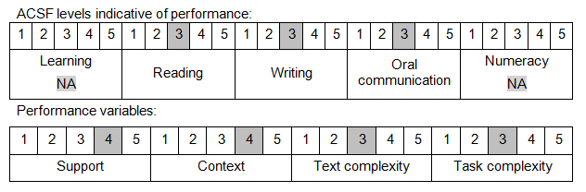

Further information on ACSF and the foundation skills underpinning this unit can be found in the Foundation Skills Guide on the GSA website.

Unit Mapping Information
This unit supersedes and is equivalent to DEFCA422B Conduct range practices.

Links
Companion Volume implementation guides are found in VETNet - https://vetnet.gov.au/Pages/TrainingDocs.aspx?q=6bdbab1e-11ed-4bc9-9cba-9e1a55d4e4a9
Companion Volume implementation guides are found in VETNet - https://vetnet.gov.au/Pages/TrainingDocs.aspx?q=6bdbab1e-11ed-4bc9-9cba-9e1a55d4e4a9
Companion Volume implementation guides are found in VETNet - https://vetnet.gov.au/Pages/TrainingDocs.aspx?q=6bdbab1e-11ed-4bc9-9cba-9e1a55d4e4a9

