DEFMIL126 Operate a light support weapon on operations
Release: 1

DEFMIL126 Operate a light support weapon on operations

Modification History
Release | Comments
1 | This unit was released in DEF Defence Training Package release 1.0 and meets the Standards for Training Packages.  This unit supersedes and is equivalent to DEFCA420B Operate a light support weapon on operations.  - Unit code updated  - Content and formatting updated to comply with the new standards  - All PC transitioned from passive to active voice  - PC 1.5 and 2.2 removed  - PC 1.2 and 1.6 merged

Application
This unit describes the skills required to effectively conduct battle shooting on operations with a light support weapon, which may include the F89 Minimi. The individual will usually operate under Orders for Opening Fire and in accordance with the Rules of Engagement.
This unit applies to those working as combat arms personnel required to operate a light support weapon on operations in a deployed operational environment.
The skills and knowledge described in this unit must be applied within the legislative, regulatory and policy environment in which they are carried out. Organisational policies and procedures must be consulted and adhered to.
Those undertaking this unit would work under supervision, usually as part of a team and will usually operate under direct orders. They would use discretion and judgement, and take responsibility for the quality of their outputs while performing specific tasks in a broad range of unpredictable contexts.
No licensing, legislative or certification requirements apply to unit at the time of publication.

Competency Field
Military Skills

Elements and Performance Criteria
ELEMENTS | PERFORMANCE CRITERIA
Elements describe the essential outcomes | Performance criteria describe the performance needed to demonstrate achievement of the element. Where bold italicised text is used, further information is detailed in the range of conditions section.
1. Handle a light support weapon | 1.1 Handle and carry light support weapon.  1.2 Identify, select, handle, secure and maintain ammunition.  1.3 Conduct weapon drills.  1.4 Adopt fire positions as required by environment and threat.
2. Apply fire with a light support weapon | 2.1 Employ weapon sighting systems and associated equipment.  2.2 Identify and engage targets as required by the operational environment.
3. Maintain and stow a light support weapon | 3.1 Clean and service weapon and associated equipment in all operational conditions.  3.2 Identify and rectify defects within limits of authority or reported to supervisor.  3.3 Complete documentation.  3.4 Secure light support weapon.

Foundation Skills
The foundation skills demands of this unit have been mapped for alignment with the Australian Core Skills Framework (ACSF). The following tables outline the performance levels indicated for successful attainment of the unit.

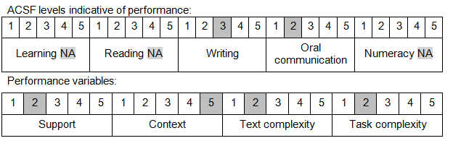

Further information on ACSF and the foundation skills underpinning this unit can be found in the Foundation Skills Guide on the GSA website.

Unit Mapping Information
This unit supersedes and is equivalent to DEFCA420B Operate a light support weapon on operations.

Links
Companion Volume implementation guides are found in VETNet - https://vetnet.gov.au/Pages/TrainingDocs.aspx?q=6bdbab1e-11ed-4bc9-9cba-9e1a55d4e4a9
Companion Volume implementation guides are found in VETNet - https://vetnet.gov.au/Pages/TrainingDocs.aspx?q=6bdbab1e-11ed-4bc9-9cba-9e1a55d4e4a9
Companion Volume implementation guides are found in VETNet - https://vetnet.gov.au/Pages/TrainingDocs.aspx?q=6bdbab1e-11ed-4bc9-9cba-9e1a55d4e4a9

