DEFMIL125 Operate a service rifle on operations
Release: 1

DEFMIL125 Operate a service rifle on operations

Modification History
Release | Comments
1 | This unit was released in DEF Defence Training Package release 1.0 and meets the Standards for Training Packages.  This unit supersedes and is equivalent to DEFCA419B Operate a service rifle on operations.  - Unit code updated  - Content and formatting updated to comply with the new standards  - All PC transitioned from passive to active voice  - PC 1.5 and 2.2 removed  - PC 1.2 and 1.6 merged

Application
This unit describes the skills required to effectively conduct battle shooting on operations with a service rifle in the Defence Force. The individual will usually operate under Orders for Opening Fire and in accordance with the Rules of Engagement.
This unit was developed for combat arms personnel required to operate a service rifle in a deployed operational environment.
The skills and knowledge described in this unit must be applied within the legislative, regulatory and policy environment in which they are carried out. Organisational policies and procedures must be consulted and adhered to.
Those undertaking this unit would work under supervision, usually as part of a team and will usually operate under direct orders. They would use discretion and judgement, and take responsibility for the quality of their outputs while performing specific tasks in a broad range of unpredictable contexts.
No licensing, legislative or certification requirements apply to unit at the time of publication.

Competency Field
Military Skills

Elements and Performance Criteria
ELEMENTS | PERFORMANCE CRITERIA
Elements describe the essential outcomes | Performance criteria describe the performance needed to demonstrate achievement of the element. Where bold italicised text is used, further information is detailed in the range of conditions section.
1. Handle a service rifle | 1.1 Handle and carry service rifle.  1.2 Identify, select, handle and secure ammunition.  1.3 Conduct weapon drills.  1.4 Adopt fire positions as required by environment and threat.
2. Apply fire with a service rifle | 2.1 Employ weapon sighting systems and associated equipment as required by the operational environment.  2.2 Identify and engage targets as required by the operational environment.
3. Maintain and stow a service rifle | 3.1 Clean and service weapon and associated equipment in all operational conditions.  3.2 Identify defects and rectify within limits of authority or report to supervisor.  3.3 Complete documentation.  3.4 Secure service rifle.

Foundation Skills
The foundation skills demands of this unit have been mapped for alignment with the Australian Core Skills Framework (ACSF). The following tables outline the performance levels indicated for successful attainment of the unit.

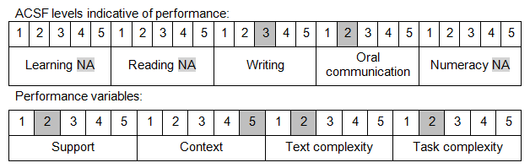

Further information on ACSF and the foundation skills underpinning this unit can be found in the Foundation Skills Guide on the GSA website.

Unit Mapping Information
This unit supersedes and is equivalent to DEFCA419B Operate a service rifle on operations.

Links
Companion Volume implementation guides are found in VETNet - https://vetnet.gov.au/Pages/TrainingDocs.aspx?q=6bdbab1e-11ed-4bc9-9cba-9e1a55d4e4a9
Companion Volume implementation guides are found in VETNet - https://vetnet.gov.au/Pages/TrainingDocs.aspx?q=6bdbab1e-11ed-4bc9-9cba-9e1a55d4e4a9
Companion Volume implementation guides are found in VETNet - https://vetnet.gov.au/Pages/TrainingDocs.aspx?q=6bdbab1e-11ed-4bc9-9cba-9e1a55d4e4a9

