DEFMIL124 Destroy targets using a direct fire guided weapons system
Release: 1

DEFMIL124 Destroy targets using a direct fire guided weapons system

Modification History
Release | Comments
1 | This unit was released in DEF Defence Training Package release 1.0 and meets the Standards for Training Packages.  This unit supersedes and is equivalent to DEFCA417B Destroy targets using a direct fire guided weapons system.  - Unit code updated  - Content and formatting updated to comply with the new standards  - All PC transitioned from passive to active voice  - PC 1.5, 2.2 and 2.5 removed  - PC 1.2 and 1.6 merged

Application
This unit describes the skills required to safely handle, aim, fire, and maintain direct fire guided weapon systems designed to destroy targets, which may include Dragon, Javelin, Milan, and TOW. The weapon is designed to be carried by a person. The individual will usually operate under Orders for Opening Fire and in accordance with the Rules of Engagement.
This unit applies to those working as combat arms personnel required to operate direct fire guided weapon systems designed to destroy targets in a deployed operational environment.
The skills and knowledge described in this unit must be applied within the legislative, regulatory and policy environment in which they are carried out. Organisational policies and procedures must be consulted and adhered to.
Those undertaking this unit would normally operate the weapon in a team environment under supervision. The operators must be thoroughly familiar with characteristics and capabilities of the guided weapon system and competent in the application of fire in an operational or simulated operational environment. They would perform specific tasks in a broad range of contexts that can be unpredictable.
No licensing, legislative, regulatory or certification requirements apply to this unit at the time of publication.

Competency Field
Military Skills

Elements and Performance Criteria
ELEMENTS | PERFORMANCE CRITERIA
Elements describe the essential outcomes | Performance criteria describe the performance needed to demonstrate achievement of the element. Where bold italicised text is used, further information is detailed in the range of conditions section.
1. Handle a direct fire guided weapon system | 1.1 Handle and carry weapon.  1.2 Identify, select, handle and secure ammunition.  1.3 Conduct weapon drills.  1.4 Adopt fire positions as required by environment and threat.
2. Fire with a direct fire guided weapon system | 2.1 Employ weapon sighting systems as required by the operational environment.  2.2 Sight, identify and select targets.  2.3 Track and engage targets as required by the operational environment.
3. Maintain and stow a direct fire guided weapon system | 3.1 Conduct maintenance.  3.2 Identify defects and rectify within limits of authority or reported to supervisor.  3.3 Complete documentation.  3.4 Secure direct fire support system.

Foundation Skills
The foundation skills demands of this unit have been mapped for alignment with the Australian Core Skills Framework (ACSF). The following tables outline the performance levels indicated for successful attainment of the unit.

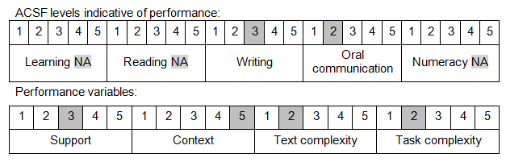

Further information on ACSF and the foundation skills underpinning this unit can be found in the Foundation Skills Guide on the GSA website.

Unit Mapping Information
This unit supersedes and is equivalent to DEFCA417B Destroy targets using a direct fire guided weapons system.

Links
Companion Volume implementation guides are found in VETNet - https://vetnet.gov.au/Pages/TrainingDocs.aspx?q=6bdbab1e-11ed-4bc9-9cba-9e1a55d4e4a9
Companion Volume implementation guides are found in VETNet - https://vetnet.gov.au/Pages/TrainingDocs.aspx?q=6bdbab1e-11ed-4bc9-9cba-9e1a55d4e4a9
Companion Volume implementation guides are found in VETNet - https://vetnet.gov.au/Pages/TrainingDocs.aspx?q=6bdbab1e-11ed-4bc9-9cba-9e1a55d4e4a9

