DEFMIL123 Employ hand operated pyrotechnics
Release: 1

DEFMIL123 Employ hand operated pyrotechnics

Modification History
Release | Comments
1 | This unit was released in DEF Defence Training Package release 1.0 and meets the Standards for Training Packages.  This unit supersedes and is equivalent to DEFCA416C Employ hand operated pyrotechnics.  - Unit code updated  - Content and formatting updated to comply with the new standards  - All PC transitioned from passive to active voice  - PC 1.4 removed

Application
This unit describes the skills required to effectively employ pyrotechnics in the Defence Force. Pyrotechnics are usually used for illumination, signalling and obscuration.
This competency was developed for combat arms personnel working with pyrotechnics, but is applicable to any individual in this field of work.
The skills and knowledge described in this unit must be applied within the legislative, regulatory and policy environment in which they are carried out. Organisational policies and procedures must be consulted and adhered to.
Those undertaking this unit would typically work independently under direct and/or indirect supervision. They use discretion and judgement, and take responsibility for the quality of their outputs. They would perform specific tasks in a range of contexts.
No licensing, legislative or certification requirements apply to unit at the time of publication.

Competency Field
Military Skills

Elements and Performance Criteria
ELEMENTS | PERFORMANCE CRITERIA
Elements describe the essential outcomes | Performance criteria describe the performance needed to demonstrate achievement of the element. Where bold italicised text is used, further information is detailed in the range of conditions section.
1. Handle pyrotechnics | 1.1 Identify and select pyrotechnics according to operational requirements.  1.2 Handle and carry pyrotechnics.  1.3 Adopt operating positions as required by circumstances and type of pyrotechnic.  1.4 Monitor environmental factors to ensure safety.
2. Operate pyrotechnics | 2.1 Activate pyrotechnics.  2.2 Achieve outcome required from using pyrotechnics.  2.3 Minimise environmental impact arising from use of pyrotechnics and recover waste products.

Foundation Skills
The foundation skills demands of this unit have been mapped for alignment with the Australian Core Skills Framework (ACSF). The following tables outline the performance levels indicated for successful attainment of the unit.

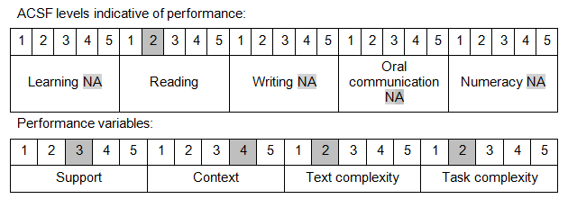

Further information on ACSF and the foundation skills underpinning this unit can be found in the Foundation Skills Guide on the GSA website.

Unit Mapping Information
This unit supersedes and is equivalent to DEFCA416C Employ hand operated pyrotechnics.

Links
Companion Volume implementation guides are found in VETNet - https://vetnet.gov.au/Pages/TrainingDocs.aspx?q=6bdbab1e-11ed-4bc9-9cba-9e1a55d4e4a9
Companion Volume implementation guides are found in VETNet - https://vetnet.gov.au/Pages/TrainingDocs.aspx?q=6bdbab1e-11ed-4bc9-9cba-9e1a55d4e4a9
Companion Volume implementation guides are found in VETNet - https://vetnet.gov.au/Pages/TrainingDocs.aspx?q=6bdbab1e-11ed-4bc9-9cba-9e1a55d4e4a9

