DEFMIL119 Operate a mortar
Release: 1

DEFMIL119 Operate a mortar

Modification History
Release | Comments
1 | This unit was released in DEF Defence Training Package release 1.0 and meets the Standards for Training Packages.  This unit supersedes and is equivalent to DEFCA412B Operate a mortar.  - Unit code updated  - Content and formatting updated to comply with the new standards  - All PC transitioned from passive to active voice  - PC 1.4 removed  - Elements 2 and 3 merged

Application
This unit describes the skills required to operate a mortar, including the 81mm mortar, in the Defence Force.
This unit applies to those working as combat arms personnel required to operate mortar equipment.
The skills and knowledge described in this unit must be applied within the legislative, regulatory and policy environment in which they are carried out. Organisational policies and procedures must be consulted and adhered to.
Those undertaking this unit would work under supervision, usually as part of a team and will operate under direct orders. They would use discretion and judgement, and take responsibility for the quality of their outputs while performing specific tasks in a range of contexts.
No licensing, legislative, regulatory or certification requirements apply to this unit at the time of publication.

Competency Field
Military Skills

Elements and Performance Criteria
ELEMENTS | PERFORMANCE CRITERIA
Elements describe the essential outcomes | Performance criteria describe the performance needed to demonstrate achievement of the element. Where bold italicised text is used, further information is detailed in the range of conditions section.
1. Position the weapon | 1.1 Prepare weapon position for firing.  1.2 Prepare ancillary equipment for use and operate as required or directed.  1.3 Prepare weapon for firing.
2. Fire the weapon | 2.1 Prepare sighting equipment for use and operate as required or directed.  2.2 Calculate firing data both manually and electronically, and communicate to supervisor.  2.3 Aim and adjust mortar as directed.  2.4 Handle and prepare ammunition.  2.5 Inspect ammunition visually and report defects to supervisor.  2.6 Conduct weapon drills.  2.7 Fire mortar in an operational environment and in accordance with orders.
3. Maintain and stow the mortar | 3.1 Clean and service weapon and associated equipment as required.  3.2 Identify and rectify defects within limits of authority or report to supervisor.  3.3 Complete documentation.  3.4 Secure mortar.

Foundation Skills
The foundation skills demands of this unit have been mapped for alignment with the Australian Core Skills Framework (ACSF). The following tables outline the performance levels indicated for successful attainment of the unit.

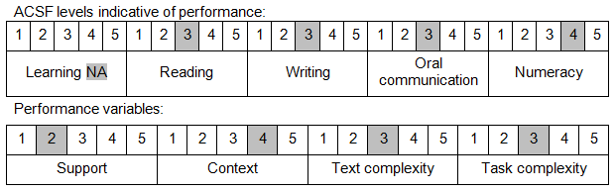

Further information on ACSF and the foundation skills underpinning this unit can be found in the Foundation Skills Guide on the GSA website.

Unit Mapping Information
This unit supersedes and is equivalent to DEFCA412B Operate a mortar.

Links
Companion Volume implementation guides are found in VETNet - https://vetnet.gov.au/Pages/TrainingDocs.aspx?q=6bdbab1e-11ed-4bc9-9cba-9e1a55d4e4a9
Companion Volume implementation guides are found in VETNet - https://vetnet.gov.au/Pages/TrainingDocs.aspx?q=6bdbab1e-11ed-4bc9-9cba-9e1a55d4e4a9
Companion Volume implementation guides are found in VETNet - https://vetnet.gov.au/Pages/TrainingDocs.aspx?q=6bdbab1e-11ed-4bc9-9cba-9e1a55d4e4a9

