DEFMIL116 Operate a shotgun
Release: 1

DEFMIL116 Operate a shotgun

Modification History
Release | Comments
1 | This unit was released in DEF Defence Training Package release 1.0 and meets the Standards for Training Packages.  This unit supersedes and is equivalent to DEFCA409B Operate a shotgun.  - Unit code updated  - Content and formatting updated to comply with the new standards  - All PC transitioned from passive to active voice  - PC 1.1, 4.1 and 4.2 removed  - Element 1 one new PC  - Elements 3 & 4 merged

Application
This unit describes the skills required to operate a shotgun, such as the Remington 870. Operating a shotgun involves the ability to safely handle, safely maintain, safely operate and safely fire it.
This unit applies to those working in Defence as combat arms personnel required to operate a shotgun.
The skills and knowledge described in this unit must be applied within the legislative, regulatory and policy environment in which they are carried out. Organisational policies and procedures must be consulted and adhered to.
Those undertaking this unit would work under supervision, usually as part of a team and will operate under direct orders. They would use discretion and judgement, and take responsibility for the quality of their outputs while performing specific tasks in a range of contexts.
No licensing, legislative, regulatory or certification requirements apply to this unit at the time of publication.

Competency Field
Military Skills

Elements and Performance Criteria
ELEMENTS | PERFORMANCE CRITERIA
Elements describe the essential outcomes | Performance criteria describe the performance needed to demonstrate achievement of the element. Where bold italicised text is used, further information is detailed in the range of conditions section.
1. Handle a shotgun | 1.1 Identify shotgun safety requirements.  1.2 Carry and handle shotgun.  1.3 Identify, select and handle ammunition.  1.4 Secure shotgun.
2. Maintain a shotgun | 2.1 Strip and assemble shotgun.  2.2 Clean and service shotgun and associated equipment.  2.3 Clean inspect and carry ammunition.  2.4 Identify and rectify defects within limits of authority or report to supervisor.  2.5 Complete relevant documentation.
3. Operate a shotgun | 3.1 Fill shotgun magazine.  3.2 Conduct weapon drills.  3.3 Apply marksmanship principles.  3.4 Adopt fire positions as required by environment and threat.  3.5 Employ weapon equipment.  3.6 Identify and engage targets.

Foundation Skills
The foundation skills demands of this unit have been mapped for alignment with the Australian Core Skills Framework (ACSF). The following tables outline the performance levels indicated for successful attainment of the unit.

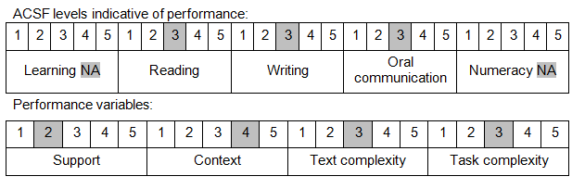

Further information on ACSF and the foundation skills underpinning this unit can be found in the Foundation Skills Guide on the GSA website.

Unit Mapping Information
This unit supersedes and is equivalent to DEFCA409B Operate a shotgun.

Links
Companion Volume implementation guides are found in VETNet - https://vetnet.gov.au/Pages/TrainingDocs.aspx?q=6bdbab1e-11ed-4bc9-9cba-9e1a55d4e4a9
Companion Volume implementation guides are found in VETNet - https://vetnet.gov.au/Pages/TrainingDocs.aspx?q=6bdbab1e-11ed-4bc9-9cba-9e1a55d4e4a9
Companion Volume implementation guides are found in VETNet - https://vetnet.gov.au/Pages/TrainingDocs.aspx?q=6bdbab1e-11ed-4bc9-9cba-9e1a55d4e4a9

