DEFMIL114 Operate a sustained fire machine gun
Release: 1

DEFMIL114 Operate a sustained fire machine gun

Modification History
Release | Comments
1 | This unit was released in DEF Defence Training Package release 1.0 and meets the Standards for Training Packages.  This unit supersedes and is equivalent to DEFCA407B Operate a sustained fire machine gun.  - Unit code updated  - Content and formatting updated to comply with the new standards  - All PC transitioned from passive to active voice  - PC 1.1 removed  - PC 1.2 and 1.4, and 4.1 and 4.3 merged

Application
This unit describes the skills required to operate a sustained fire machine gun. It involves the ability to safely handle, safely maintain, safely operate and safely fire the sustained fire machine gun. A sustained fire machine gun is normally fired from a tripod utilising a sighting system enabling direct and indirect fire.
This unit applies to those working as combat arms personnel required to operate a sustained fire machine gun.
The skills and knowledge described in this unit must be applied within the legislative, regulatory and policy environment in which they are carried out. Organisational policies and procedures must be consulted and adhered to.
Those undertaking this unit would work under supervision, usually as part of a team and will operate under direct orders. They would use discretion and judgement, and take responsibility for the quality of their outputs while performing specific tasks in a range of contexts.
No licensing, legislative, regulatory or certification requirements apply to this unit at the time of publication.

Competency Field
Military Skills

Elements and Performance Criteria
ELEMENTS | PERFORMANCE CRITERIA
Elements describe the essential outcomes | Performance criteria describe the performance needed to demonstrate achievement of the element. Where bold italicised text is used, further information is detailed in the range of conditions section.
1. Handle a sustained fire machine gun | 1.1 Identify, select and safely handle ammunition.  1.2 Secure, handle and carry sustained fire machine gun.
2. Maintain a sustained fire machine gun | 2.1 Strip and assemble sustained fire machine gun.  2.2 Clean and service sustained fire machine gun and associated equipment.  2.3 Clean, inspect, carry and secure ammunition.  2.4 Identify and rectify defects within limits of authority or report to supervisor.  2.5 Complete documentation.
3. Operate a sustained fire machine gun | 3.1 Conduct weapon drills.  3.2 Apply marksmanship principles.  3.3 Adopt fire positions as required by environment and threat.  3.4 Employ weapon equipment.
4. Fire a sustained fire machine gun | 4.1 Identify and engage targets to fire sustained fire machine gun.  4.2 Comply with Range Safety Brief and Practice Brief when firing a sustained fire machine gun on a range.

Foundation Skills
The foundation skills demands of this unit have been mapped for alignment with the Australian Core Skills Framework (ACSF). The following tables outline the performance levels indicated for successful attainment of the unit.

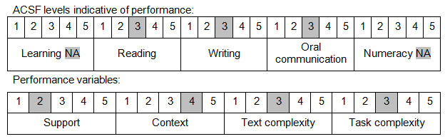

Further information on ACSF and the foundation skills underpinning this unit can be found in the Foundation Skills Guide on the GSA website.

Unit Mapping Information
This unit supersedes and is equivalent to DEFCA407B Operate a sustained fire machine gun.

Links
Companion Volume implementation guides are found in VETNet - https://vetnet.gov.au/Pages/TrainingDocs.aspx?q=6bdbab1e-11ed-4bc9-9cba-9e1a55d4e4a9
Companion Volume implementation guides are found in VETNet - https://vetnet.gov.au/Pages/TrainingDocs.aspx?q=6bdbab1e-11ed-4bc9-9cba-9e1a55d4e4a9
Companion Volume implementation guides are found in VETNet - https://vetnet.gov.au/Pages/TrainingDocs.aspx?q=6bdbab1e-11ed-4bc9-9cba-9e1a55d4e4a9

