DEFMIL113 Operate a service pistol
Release: 1

DEFMIL113 Operate a service pistol

Modification History
Release | Comments
1 | This unit was released in DEF Defence Training Package release 1.0 and meets the Standards for Training Packages.  This unit supersedes and is equivalent to DEFCA406B Operate a service pistol.  - Unit code updated  - Content and formatting updated to comply with the new standards  - All PC transitioned from passive to active voice  - PC 1.1 removed  - PC 1.2 and 1.4, and 4.1 and 4.3 merged

Application
This unit describes the skills required to operate a service pistol. Operating a service pistol involves the ability to safely handle, safely maintain, safely operate and safely fire the service pistol.
This unit applies to those working as combat arms personnel required to operate a service pistol.
The skills and knowledge described in this unit must be applied within the legislative, regulatory and policy environment in which they are carried out. Organisational policies and procedures must be consulted and adhered to.
Those undertaking this unit would work independently or as part of a group usually in self-defence. They would work under direct and/or indirect supervision, use discretion and judgement, and take responsibility for the quality of their outputs while performing specific tasks in a range of contexts.
No licensing, legislative or certification requirements apply to unit at the time of publication.

Competency Field
Military Skills

Elements and Performance Criteria
ELEMENTS | PERFORMANCE CRITERIA
Elements describe the essential outcomes | Performance criteria describe the performance needed to demonstrate achievement of the element. Where bold italicised text is used, further information is detailed in the range of conditions section.
1. Handle a service pistol | 1.1 Identify, select and safely handle ammunition.  1.2 Secure, handle and carry service pistol.
2. Maintain a service pistol | 2.1 Strip and assemble service pistol.  2.2 Clean and maintain pistol and associated equipment.  2.3 Clean, inspect, carry and secure ammunition.  2.4 Identify and rectify defects within limits of authority or report them to supervisor.  2.5 Complete documentation.
3. Operate a service pistol | 3.1 Fill and empty service pistol magazine.  3.2 Conduct weapon drills.  3.3 Apply marksmanship principles.  3.4 Adopt fire positions as required by environment and threat.  3.5 Employ weapon equipment.
4. Fire a service pistol | 4.1 Identify and engage targets to fire a service pistol.  4.2 Comply with Range Safety Brief and Practice Brief when firing a service pistol on a range.

Foundation Skills
The foundation skills demands of this unit have been mapped for alignment with the Australian Core Skills Framework (ACSF). The following tables outline the performance levels indicated for successful attainment of the unit.

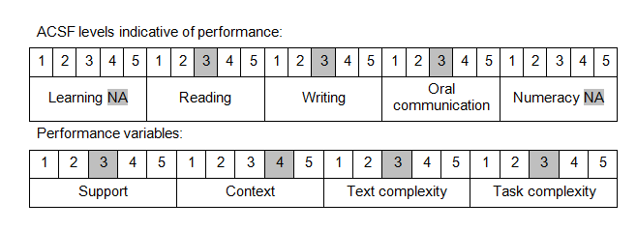

Further information on ACSF and the foundation skills underpinning this unit can be found in the Foundation Skills Guide on the GSA website.

Unit Mapping Information
This unit supersedes and is equivalent to DEFCA406B Operate a service pistol.

Links
Companion Volume implementation guides are found in VETNet - https://vetnet.gov.au/Pages/TrainingDocs.aspx?q=6bdbab1e-11ed-4bc9-9cba-9e1a55d4e4a9
Companion Volume implementation guides are found in VETNet - https://vetnet.gov.au/Pages/TrainingDocs.aspx?q=6bdbab1e-11ed-4bc9-9cba-9e1a55d4e4a9
Companion Volume implementation guides are found in VETNet - https://vetnet.gov.au/Pages/TrainingDocs.aspx?q=6bdbab1e-11ed-4bc9-9cba-9e1a55d4e4a9

