DEFMIL093 Assist in the construction of dry gap crossings
Release: 1

DEFMIL093 Assist in the construction of dry gap crossings

Modification History
Release | Comments
1 | This unit was released in DEF Defence Training Package release 1.0 and meets the Standards for Training Packages.  This unit supersedes and is equivalent to DEFCA322 Assist in the construction of dry gap crossings.  - Unit code updated  - Content and formatting updated to comply with the new standards  - All PC transitioned from passive to active voice  - PC 2.3 removed  - PC 1.3 and 3.2 revised

Application
This unit describes the skills required to assist in the preparation, construction, maintenance and recovery of dry gap crossing bridging equipment to cross any form of gap, including rivers and streams, to facilitate the movement of personnel, vehicles, cargo and equipment. When the crossing is no longer required the bridge is either recovered to storage or redeployed to another crossing.
This unit applies to for combat engineer personnel involved in the construction of dry gap crossings in a deployed operational environment.
The skills and knowledge described in this unit must be applied within the legislative, regulatory and policy environment in which they are carried out. Organisational policies and procedures must be consulted and adhered to.
Those undertaking this unit would usually be engaged in bridge construction as part of a team under supervision, but may undertake some autonomous tasks. They would perform routine tasks in a broad range of unpredictable contexts.
No licensing, legislative or certification requirements apply to unit at the time of publication.

Competency Field
Military Skills

Elements and Performance Criteria
ELEMENTS | PERFORMANCE CRITERIA
Elements describe the essential outcomes | Performance criteria describe the performance needed to demonstrate achievement of the element. Where bold italicised text is used, further information is detailed in the range of conditions section.
1. Plan and prepare for dry gap crossing operations | 1.1 Select and wear appropriate personal protective equipment.  1.2 Conduct site layout and preparation.  1.3 Check dry gap crossing bridging components against inventory and materials list for completeness and prepare for operation.  1.4 Report faults and deficiencies in bridging components.  1.5 Select tools and equipment, check for serviceability and report faults.
2. Construct a dry gap crossing | 2.1 Assemble and adjust ready for use jigs, fixtures and tools to be used in construction.  2.2 Assemble bridge components and check for compliance, accuracy and alignment.
3. Maintain and clean-up site and equipment | 3.1 Maintain gap crossing sites and crossing systems.  3.2 Recover, clean and maintain gap crossing equipment, tools and unused materials.  3.3 Document and report faults and deficiencies in gap crossing equipment, tools and unused materials.  3.4 Store or redeploy gap crossing equipment, tools and materials.

Foundation Skills
The foundation skills demands of this unit have been mapped for alignment with the Australian Core Skills Framework (ACSF). The following tables outline the performance levels indicated for successful attainment of the unit.

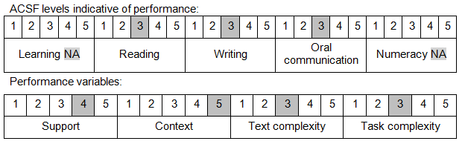

Further information on ACSF and the foundation skills underpinning this unit can be found in the Foundation Skills Guide on the GSA website.

Unit Mapping Information
This unit supersedes and is equivalent to DEFCA322 Assist in the construction of dry gap crossings.

Links
Companion Volume implementation guides are found in VETNet - https://vetnet.gov.au/Pages/TrainingDocs.aspx?q=6bdbab1e-11ed-4bc9-9cba-9e1a55d4e4a9
Companion Volume implementation guides are found in VETNet - https://vetnet.gov.au/Pages/TrainingDocs.aspx?q=6bdbab1e-11ed-4bc9-9cba-9e1a55d4e4a9
Companion Volume implementation guides are found in VETNet - https://vetnet.gov.au/Pages/TrainingDocs.aspx?q=6bdbab1e-11ed-4bc9-9cba-9e1a55d4e4a9

