DEFMIL085 Construct equipment bridging
Release: 1

DEFMIL085 Construct equipment bridging

Modification History
Release | Comments
1 | This unit was released in DEF Defence Training Package release 1.0 and meets the Standards for Training Packages.  This unit supersedes and is equivalent to DEFCA312B Construct equipment bridging.  - Unit code updated  - Content and formatting updated to comply with the new standards  - All PC transitioned from passive to active voice  - PC 1.10 removed

Application
This unit describes the skills required to facilitate the movement of personnel, vehicles, cargo and equipment through bridging. Equipment bridging is constructed from designed and certified bridge modules and parts to provide a temporary or permanent bridge over a gap.
Bridges will normally be constructed on a temporary basis under field conditions to meet the operational need to provide a crossing point over a gap for personnel and equipment. When the crossing is no longer required the bridge is either recovered to storage or redeployed to another crossing.
This unit applies to combat engineer personnel who are required to construct and recover gap crossing bridging equipment in a deployed operational environment.
The skills and knowledge described in this unit must be applied within the legislative, regulatory and policy environment in which they are carried out. Organisational policies and procedures must be consulted and adhered to.
Those undertaking this unit would work independently and lead a team. They use discretion and judgement, and take responsibility for the quality of their outputs. They would perform routine tasks in a broad range of unpredictable contexts.
No licensing, legislative or certification requirements apply to unit at the time of publication.

Competency Field
Military Skills

Elements and Performance Criteria
ELEMENTS | PERFORMANCE CRITERIA
Elements describe the essential outcomes | Performance criteria describe the performance needed to demonstrate achievement of the element. Where bold italicised text is used, further information is detailed in the range of conditions section.
1. Prepare and plan for gap crossing | 1.1 Receive and process requirement and confirm with higher authority as necessary.  1.2 Identify resource availability and serviceability and determine constraints.  1.3 Conduct site survey, risk and environmental assessment.  1.4 Select suitable bridge design based on site survey and available resources.  1.5 Develop construction/dismantle plan in accordance with design, resources, risks and environmental considerations.  1.6 Refer problems that cannot be resolved locally to higher authority for resolution.  1.7 Confirm and monitor competence of team members.  1.8 Brief construction team.  1.9 Liaise with outside agencies.
2. Construct gap crossing | 2.1 Direct and supervise construction team.  2.2 Recognise and respond to unexpected situations that require a quick and decisive response.  2.3 Check security, alignment and stability.  2.4 Organise and direct support from outside agencies.  2.5 Provide technical advice to higher authority or support agencies.  2.6 Maintain gap crossing site and gap crossing.
3. Dismantle gap crossing and refurbish site and equipment | 3.1 Direct and supervise construction team in accordance with dismantle plan.  3.2 Recover, clean and maintain gap crossing equipment, tools and materials.  3.3 Store or redeploy gap crossing equipment, tools and materials.  3.4 Refurbish site in accordance with environmental requirements.  3.5 Complete documentation.  3.6 Conduct post activity analysis and make recommendations.

Foundation Skills
The foundation skills demands of this unit have been mapped for alignment with the Australian Core Skills Framework (ACSF). The following tables outline the performance levels indicated for successful attainment of the unit.

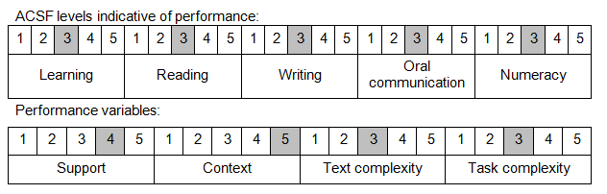

Further information on ACSF and the foundation skills underpinning this unit can be found in the Foundation Skills Guide on the GSA website.

Unit Mapping Information
This unit supersedes and is equivalent to DEFCA312B Construct equipment bridging.

Links
Companion Volume implementation guides are found in VETNet - https://vetnet.gov.au/Pages/TrainingDocs.aspx?q=6bdbab1e-11ed-4bc9-9cba-9e1a55d4e4a9
Companion Volume implementation guides are found in VETNet - https://vetnet.gov.au/Pages/TrainingDocs.aspx?q=6bdbab1e-11ed-4bc9-9cba-9e1a55d4e4a9
Companion Volume implementation guides are found in VETNet - https://vetnet.gov.au/Pages/TrainingDocs.aspx?q=6bdbab1e-11ed-4bc9-9cba-9e1a55d4e4a9

