DEFMIL071 Supervise the destruction of hostile air targets using line of sight ground based AD weapon systems
Release: 1

DEFMIL071 Supervise the destruction of hostile air targets using line of sight ground based AD weapon systems

Modification History
Release | Comments
1 | This unit was released in DEF Defence Training Package release 1.0 and meets the Standards for Training Packages.  This unit supersedes and is equivalent to DEFCA213 Supervise the destruction of hostile air targets using line of sight ground based air defence weapon systems.  - Unit code updated  - Content and formatting updated to comply with the new standards  - All PC transitioned from passive to active voice

Application
This unit describes the skills required to supervise and control all aspects of the operation of a direct fire ground based missile system designed to destroy hostile aircraft. It is specifically written for visual range ground based air defence weapon systems. The control of the ground based missile system requires target interrogation, analysis, engagement and decision making based on tactical information, situational awareness and observed target activity.
This unit applies to combat arms personnel involved in the operation of a direct fire ground based missile system in a deployed operational environment.
The skills and knowledge described in this unit must be applied within the legislative, regulatory and policy environment in which they are carried out. Organisational policies and procedures must be consulted and adhered to.
Those undertaking this unit would work under the commander’s direction, however they must be able to act independently. They use discretion and judgement, and take responsibility for the quality of their outputs. They would perform specific tasks in a broad range of unpredictable contexts.
No licensing, legislative or certification requirements apply to unit at the time of publication.

Competency Field
Military Skills

Elements and Performance Criteria
ELEMENTS | PERFORMANCE CRITERIA
Elements describe the essential outcomes | Performance criteria describe the performance needed to demonstrate achievement of the element. Where bold italicised text is used, further information is detailed in the range of conditions section.
1. Prepare and deploy | 1.1 Determine and organise resources required for the performance of the task in accordance with orders.  1.2 Report identified problems/shortfalls to immediate supervisor.  1.3 Move to a directed location and maintain concealment, in accordance with orders.  1.4 Deploy ground based air defence system in accordance with orders.  1.5 Establish and integrate system and check for functionality.
2. Control the engagement of targets | 2.1 Analyse advice on the operational situation to inform the engagement process.  2.2 Direct and control ground based air defence system operations in accordance with orders.  2.3 Transmit operational data to the command post.  2.4 Rectify minor incidents.  2.5 Report major incidents beyond own level of authority or competence to manager/s and take action as directed.
3. Conduct maintenance | 3.1 Supervise operator maintenance activities.  3.2 Perform maintenance activities.
4. Redeploy | 4.1 Prepare for redeployment.  4.2 Move from one directed location to another in accordance with orders.

Foundation Skills
The foundation skills demands of this unit have been mapped for alignment with the Australian Core Skills Framework (ACSF). The following tables outline the performance levels indicated for successful attainment of the unit.

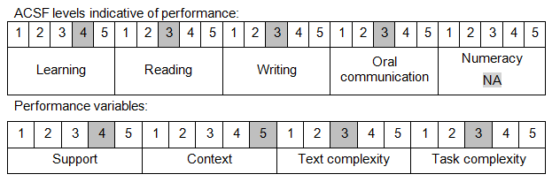

Further information on ACSF and the foundation skills underpinning this unit can be found in the Foundation Skills Guide on the GSA website.

Unit Mapping Information
This unit supersedes and is equivalent to DEFCA213 Supervise the destruction of hostile air targets using line of sight ground based air defence weapon systems.

Links
Companion Volume implementation guides are found in VETNet - https://vetnet.gov.au/Pages/TrainingDocs.aspx?q=6bdbab1e-11ed-4bc9-9cba-9e1a55d4e4a9
Companion Volume implementation guides are found in VETNet - https://vetnet.gov.au/Pages/TrainingDocs.aspx?q=6bdbab1e-11ed-4bc9-9cba-9e1a55d4e4a9
Companion Volume implementation guides are found in VETNet - https://vetnet.gov.au/Pages/TrainingDocs.aspx?q=6bdbab1e-11ed-4bc9-9cba-9e1a55d4e4a9

