DEFMIL070 Observe targets and engage with joint asset firepower from any agency
Release: 1

DEFMIL070 Observe targets and engage with joint asset firepower from any agency

Modification History
Release | Comments
1 | This unit was released in DEF Defence Training Package release 1.0 and meets the Standards for Training Packages.  This unit supersedes and is equivalent to DEFCA212 Observe targets and engage with joint asset firepower from any agency.  - Unit code updated  - Content and formatting updated to comply with the new standards  - All PC transitioned from passive to active voice  - PC 3.3 removed

Application
This unit describes the skills required to observe targets remotely from the firepower locations and to provide advice so that single or multi-agency firepower can be employed to engage target/s. Agencies may include armour, artillery, coalition forces, close air support, helicopters, mortars, naval gun support, and tactical unmanned aerial vehicle.
While this work will be undertaken as part of a team and under the commander’s direction, the capacity to act independently may also be required should communications with the commander breakdown.
This unit applies to combat arms personnel required to observe targets and to direct joint asset firepower from any agency to destroy/neutralise multiple targets in a deployed operational environment.
The skills and knowledge described in this unit must be applied within the legislative, regulatory and policy environment in which they are carried out. Organisational policies and procedures must be consulted and adhered to.
Those undertaking this unit would typically work as part of a team under direct and/or indirect supervision, but also must be prepared to act independently. They use discretion and judgement, and take responsibility for the quality of their outputs. They would perform routine tasks in a broad range of unpredictable contexts.
No licensing, legislative or certification requirements apply to unit at the time of publication.

Competency Field
Military Skills

Elements and Performance Criteria
ELEMENTS | PERFORMANCE CRITERIA
Elements describe the essential outcomes | Performance criteria describe the performance needed to demonstrate achievement of the element. Where bold italicised text is used, further information is detailed in the range of conditions section.
1. Occupy and prepare a location | 1.1 Occupy an appropriate vantage point and maintain concealment throughout the operation.  1.2 Establish occupied position.  1.3 Establish reference points and document information.  1.4 Observe and monitor possible threats so an appropriate plan of action can be prepared.
2. Plan the engagement of firepower | 2.1 Transmit a warning order for intent of operations to the command post.  2.2 Use advice on overall operational plan to inform the planning process.  2.3 Make requests for resources outside own organisation to the command post when required.  2.4 Establish and record target data.  2.5 Calculate rate of movement of own personnel from available data.  2.6 Calculate resources for effective fire on targets and rates of fire.  2.7 Prioritise targets.  2.8 Develop and transmit schedule to the command post or liaison with other agency to organise engagement schedule.
3. Monitor fire on target | 3.1 Communicate directly with other agencies to coordinate engagement procedures.  3.2 Maintain communications with stakeholders throughout operation.  3.3 Complete target analysis after impact and if necessary, refer to appropriate agency command centre.  3.4 Provide advice to terminate as required.  3.5 Maintain records.
4. Withdraw from an occupied location | 4.1 Recondition occupied position and remove all evidence of occupation.  4.2 Conduct a secure withdrawal from the occupied position.

Foundation Skills
The foundation skills demands of this unit have been mapped for alignment with the Australian Core Skills Framework (ACSF). The following tables outline the performance levels indicated for successful attainment of the unit.

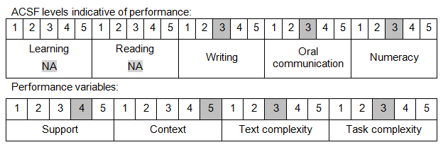

Further information on ACSF and the foundation skills underpinning this unit can be found in the Foundation Skills Guide on the GSA website.

Unit Mapping Information
This unit supersedes and is equivalent to DEFCA212 Observe targets and engage with joint asset firepower from any agency.

Links
Companion Volume implementation guides are found in VETNet - https://vetnet.gov.au/Pages/TrainingDocs.aspx?q=6bdbab1e-11ed-4bc9-9cba-9e1a55d4e4a9
Companion Volume implementation guides are found in VETNet - https://vetnet.gov.au/Pages/TrainingDocs.aspx?q=6bdbab1e-11ed-4bc9-9cba-9e1a55d4e4a9
Companion Volume implementation guides are found in VETNet - https://vetnet.gov.au/Pages/TrainingDocs.aspx?q=6bdbab1e-11ed-4bc9-9cba-9e1a55d4e4a9

