DEFMIL069 Supervise indirect fire weapons
Release: 1

DEFMIL069 Supervise indirect fire weapons

Modification History
Release | Comments
1 | This unit was released in DEF Defence Training Package release 1.0 and meets the Standards for Training Packages.  This unit supersedes and is equivalent to DEFCA210B Supervise indirect fire weapons.  - Unit code updated  - Content and formatting updated to comply with the new standards  - All PC transitioned from passive to active voice  - PC 1.4 removed

Application
This unit describes the skills required to supervise and control all aspects of the operation of indirect fire weapons. While this work will be undertaken under the commander’s direction the individual must be able to act independently as required by the circumstances.
This unit applies to combat arms personnel who are required to supervise and control all aspects of the operation of an indirect fire weapons in a deployed operational environment.
The skills and knowledge described in this unit must be applied within the legislative, regulatory and policy environment in which they are carried out. Organisational policies and procedures must be consulted and adhered to.
Those undertaking this unit would lead a team under indirect supervision. They use discretion and judgement, and take responsibility for the quality of their outputs. They would perform routine tasks in a range of unpredictable contexts.
No licensing, legislative or certification requirements apply to unit at the time of publication.

Competency Field
Military Skills

Elements and Performance Criteria
ELEMENTS | PERFORMANCE CRITERIA
Elements describe the essential outcomes | Performance criteria describe the performance needed to demonstrate achievement of the element. Where bold italicised text is used, further information is detailed in the range of conditions section.
1. Prepare and deploy an indirect fire weapon | 1.1 Determine and organise resources required.  1.2 Report identified problems/shortfalls to immediate supervisor.  1.3 Deploy indirect fire weapon in accordance with orders.
2. Engage targets with indirect fire | 2.1 Direct and control indirect fire weapon operations.  2.2 Select appropriate ammunition.  2.3 Rectify minor incidents.  2.4 Report major incidents beyond own level of authority or competence to manager/s and take action as directed.
3. Maintain indirect fire weapons | 3.1 Supervise operator maintenance activities.  3.2 Complete maintenance activities.

Foundation Skills
The foundation skills demands of this unit have been mapped for alignment with the Australian Core Skills Framework (ACSF). The following tables outline the performance levels indicated for successful attainment of the unit.

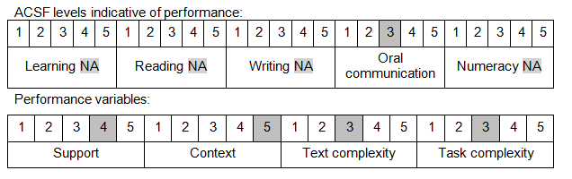

Further information on ACSF and the foundation skills underpinning this unit can be found in the Foundation Skills Guide on the GSA website.

Unit Mapping Information
This unit supersedes and is equivalent to DEFCA210B Supervise indirect fire weapons.

Links
Companion Volume implementation guides are found in VETNet - https://vetnet.gov.au/Pages/TrainingDocs.aspx?q=6bdbab1e-11ed-4bc9-9cba-9e1a55d4e4a9
Companion Volume implementation guides are found in VETNet - https://vetnet.gov.au/Pages/TrainingDocs.aspx?q=6bdbab1e-11ed-4bc9-9cba-9e1a55d4e4a9
Companion Volume implementation guides are found in VETNet - https://vetnet.gov.au/Pages/TrainingDocs.aspx?q=6bdbab1e-11ed-4bc9-9cba-9e1a55d4e4a9

