DEFMIL063 Produce meteorological data
Release: 1

DEFMIL063 Produce meteorological data

Modification History
Release | Comments
1 | This unit was released in DEF Defence Training Package release 1.0 and meets the Standards for Training Packages.  This unit supersedes and is equivalent to DEFCA203B Produce meteorological data.  - Unit code updated  - Content and formatting updated to comply with the new standards  - All PC transitioned from passive to active voice  - PC 1.2 and 2.4 removed  - PC 1.1 and 1.3 merged  - Elements 1 and 2 merged

Application
This unit describes the skills required to produce meteorological data in terms of likely weather conditions in areas, which is to be used to inform operations.
This unit was developed for those working as combat arms personnel required to produce meteorological data in areas which are to be used to conduct Defence operations, but is applicable to any individual in this field of work.
The skills and knowledge described in this unit must be applied within the legislative, regulatory and policy environment in which they are carried out. Organisational policies and procedures must be consulted and adhered to.
Those undertaking this unit would work as part of a team under supervision. They would use discretion and judgement, and take responsibility for the quality of their outputs. They would perform routine tasks in a broad range of contexts.
No licensing, legislative, regulatory or certification requirements apply to this unit at the time of publication.

Competency Field
Military Skills

Elements and Performance Criteria
ELEMENTS | PERFORMANCE CRITERIA
Elements describe the essential outcomes | Performance criteria describe the performance needed to demonstrate achievement of the element. Where bold italicised text is used, further information is detailed in the range of conditions section.
1. Gather meteorological data | 1.1 Select, prepare and check equipment for serviceability.  1.2 Fill and launch weather balloon or other device in order to collect atmospheric information.  1.3 Collect surface data using meteorological equipment.  1.4 Operate receiving equipment.
2. Monitor and report meteorological information | 2.1 Communicate meteorological information as directed by supervisor.  2.2 Monitor incoming data to identify changing conditions and notify supervisor about any changes.  2.3 Maintain and/or refurbish meteorological equipment.  2.4 Complete and maintain documentation and records.

Foundation Skills
The foundation skills demands of this unit have been mapped for alignment with the Australian Core Skills Framework (ACSF). The following tables outline the performance levels indicated for successful attainment of the unit.

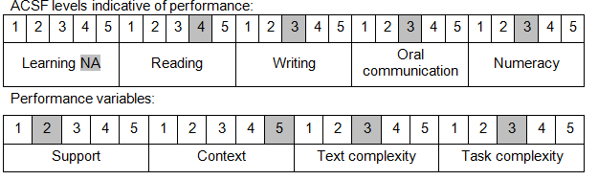

Further information on ACSF and the foundation skills underpinning this unit can be found in the Foundation Skills Guide on the GSA website.

Unit Mapping Information
This unit supersedes and is equivalent to DEFCA203B Produce meteorological data.

Links
Companion Volume implementation guides are found in VETNet - https://vetnet.gov.au/Pages/TrainingDocs.aspx?q=6bdbab1e-11ed-4bc9-9cba-9e1a55d4e4a9
Companion Volume implementation guides are found in VETNet - https://vetnet.gov.au/Pages/TrainingDocs.aspx?q=6bdbab1e-11ed-4bc9-9cba-9e1a55d4e4a9
Companion Volume implementation guides are found in VETNet - https://vetnet.gov.au/Pages/TrainingDocs.aspx?q=6bdbab1e-11ed-4bc9-9cba-9e1a55d4e4a9

