DEFMIL062 Conduct field survey to determine fixation and orientation
Release: 1

DEFMIL062 Conduct field survey to determine fixation and orientation

Modification History
Release | Comments
1 | This unit was released in DEF Defence Training Package release 1.0 and meets the Standards for Training Packages.  This unit supersedes and is equivalent to DEFCA202B Conduct field survey to determine fixation and orientation.  - Unit code updated  - Content and formatting updated to comply with the new standards  - All PC transitioned from passive to active voice

Application
This unit describes the skills required to conduct a field survey to determine fixation and orientation. This survey is normally conducted by at least two people. One person will be the observer and one will record data. This unit of competency covers both roles.
This unit was developed for combat arms personnel required to conduct a field survey to determine fixation and orientation in a deployed operational environment, but is applicable to any individual in this field of work.
The skills and knowledge described in this unit must be applied within the legislative, regulatory and policy environment in which they are carried out. Organisational policies and procedures must be consulted and adhered to.
Those undertaking this unit would work as part of a two-man team under direct and/or indirect supervision. They would use discretion and judgement, and take responsibility for the quality of their outputs. They would perform routine tasks in a broad range of contexts that could be unpredictable.
No licensing, legislative, regulatory or certification requirements apply to this unit at the time of publication.

Competency Field
Military Skills

Elements and Performance Criteria
ELEMENTS | PERFORMANCE CRITERIA
Elements describe the essential outcomes | Performance criteria describe the performance needed to demonstrate achievement of the element. Where bold italicised text is used, further information is detailed in the range of conditions section.
1. Prepare for survey | 1.1 Identify purpose and requirements of the survey from written or oral instructions from supervisor.  1.2 Confirm and clarify specifications of the survey with supervisor.  1.3 Select equipment required for the survey and check for serviceability.
2. Conduct survey | 2.1 Operate survey equipment to determine orientation and fixation as determined by the survey scheme.  2.2 Record data from the survey in field book or other proforma.  2.3 Verify results for omissions and errors by re checking visual clues in measurements or actual data.  2.4 Communicate survey data.  2.5 Establish and record survey control points.  2.6 Liaise with supervisor and colleagues regularly throughout the survey activity to ensure smooth operation and progress.  2.7 Maintain survey equipment.

Foundation Skills
The foundation skills demands of this unit have been mapped for alignment with the Australian Core Skills Framework (ACSF). The following tables outline the performance levels indicated for successful attainment of the unit.

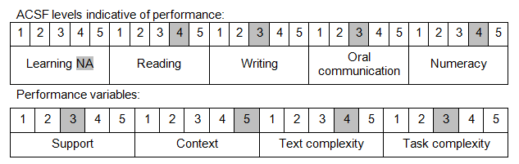

Further information on ACSF and the foundation skills underpinning this unit can be found in the Foundation Skills Guide on the GSA website.

Unit Mapping Information
This unit supersedes and is equivalent to DEFCA202B Conduct field survey to determine fixation and orientation.

Links
Companion Volume implementation guides are found in VETNet - https://vetnet.gov.au/Pages/TrainingDocs.aspx?q=6bdbab1e-11ed-4bc9-9cba-9e1a55d4e4a9
Companion Volume implementation guides are found in VETNet - https://vetnet.gov.au/Pages/TrainingDocs.aspx?q=6bdbab1e-11ed-4bc9-9cba-9e1a55d4e4a9
Companion Volume implementation guides are found in VETNet - https://vetnet.gov.au/Pages/TrainingDocs.aspx?q=6bdbab1e-11ed-4bc9-9cba-9e1a55d4e4a9

