DEFMIL043 Supervise an armoured vehicle and crew
Release: 1

DEFMIL043 Supervise an armoured vehicle and crew

Modification History
Release | Comments
1 | This unit was released in DEF Defence Training Package release 1.0 and meets the Standards for Training Packages.  This unit supersedes and is equivalent to DEFCA106 Supervise an armoured vehicle and crew.  - Unit code updated  - Content and formatting updated to comply with the new standards  - All PC transitioned from passive to active voice  - PC 2.1, 2.2, 2.4, 2.5 and 2.8 removed  - PC 2.11 and 2.12 merged

Application
This unit describes the skills required to command, lead and manage an armoured vehicle and its crew on operations under extreme conditions in a high risk environment. Command is the authority a commander in the military service lawfully exercises over subordinates by virtue of rank or assignment.
This unit applies to combat arms soldiers working within an operational zone in Defence.
The skills and knowledge described in this unit must be applied within the legislative, regulatory and policy environment in which they are carried out. Organisational policies and procedures must be consulted and adhered to.
Those undertaking this unit would work as individuals and as part of an armoured vehicle crew, under direct and/or indirect supervision while supervising others. They would use discretion and judgement, and take responsibility for the quality of their outputs. They would perform complex tasks in a broad range of contexts that can be unpredictable.
No licensing, legislative or certification requirements apply to unit at the time of publication.

Competency Field
Military Skills

Elements and Performance Criteria
ELEMENTS | PERFORMANCE CRITERIA
Elements describe the essential outcomes | Performance criteria describe the performance needed to demonstrate achievement of the element. Where bold italicised text is used, further information is detailed in the range of conditions section.
1. Prepare the armoured vehicle for operation | 1.1 Assess and maintain crew competence.  1.2 Ensure crew is prepared.  1.3 Manage crew personnel administration.  1.4 Receive, interpret and accept requirement to supervise the crew, its weapons, and ancillary equipment.  1.5 Ensure vehicle is checked for serviceability and prepared for operations.  1.6 Determine and manage constraints and risks relevant to the task.  1.7 Supervise identification, handling and preparation of in service ammunition.  1.8 Determine resources required for the performance of the task.  1.9 Report identified problems/shortfalls to supervisor.  1.10 Supervise deployment of the armoured fighting vehicle into areas of operations.
2. Supervise and command the operation of the armoured vehicle | 2.1 Coordinate and conduct battle procedure.  2.2 Drive the vehicle at a basic level in accordance with standing orders for vehicle operations.  2.3 Supervise crew tasks when employing the vehicle.  2.4 Apply vehicle tactical operating techniques.  2.5 Supervise the operation of the vehicle communications systems.  2.6 Assess incidents, deal with minor incidents, report major ones to manager and take appropriate actions.
3. Supervise the completion of armoured vehicle tasks | 3.1 Complete and maintain documentation including reports and returns.  3.2 Supervise and ensure maintenance is conducted.  3.3 Debrief crew on completed operations.

Foundation Skills
The foundation skills demands of this unit have been mapped for alignment with the Australian Core Skills Framework (ACSF). The following tables outline the performance levels indicated for successful attainment of the unit.

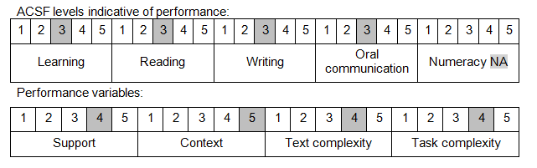

Further information on ACSF and the foundation skills underpinning this unit can be found in the Foundation Skills Guide on the GSA website.

Unit Mapping Information
This unit supersedes and is equivalent to DEFCA106 Supervise an armoured vehicle and crew.

Links
Companion Volume implementation guides are found in VETNet - https://vetnet.gov.au/Pages/TrainingDocs.aspx?q=6bdbab1e-11ed-4bc9-9cba-9e1a55d4e4a9
Companion Volume implementation guides are found in VETNet - https://vetnet.gov.au/Pages/TrainingDocs.aspx?q=6bdbab1e-11ed-4bc9-9cba-9e1a55d4e4a9
Companion Volume implementation guides are found in VETNet - https://vetnet.gov.au/Pages/TrainingDocs.aspx?q=6bdbab1e-11ed-4bc9-9cba-9e1a55d4e4a9

