DEFMIL042 Operate and maintain armoured vehicle weapon systems
Release: 1

DEFMIL042 Operate and maintain armoured vehicle weapon systems

Modification History
Release | Comments
1 | This unit was released in DEF Defence Training Package release 1.0 and meets the Standards for Training Packages.  This unit supersedes and is equivalent to DEFCA105 Operate and maintain armoured vehicle weapon systems  - Unit code updated  - Content and formatting updated to comply with the new standards  - All PC transitioned from passive to active voice  - PC 1.3 removed

Application
This unit describes the skills required to operate armoured vehicle direct fire weapon systems to effectively produce fire. Direct fire weapon systems are integral to, and operated in conjunction with, armoured vehicles. Direct fire is primarily used during conventional operations to establish fire supremacy in order to destroy the enemy’s will to operate. It can also be applied in accordance with the Rules of Engagement during security operations.
This unit applies to those working as combat arms soldiers working within an operational zone in Defence.
The skills and knowledge described in this unit must be applied within the legislative, regulatory and policy environment in which they are carried out. Organisational policies and procedures must be consulted and adhered to.
Those undertaking this unit work independently and as part of a team under direct and/or indirect supervision, use discretion and judgement, and take responsibility for the quality of their outputs. They would perform specific tasks in a broad range of unpredictable contexts.
No licensing, legislative or certification requirements apply to unit at the time of publication.

Competency Field
Military Skills

Elements and Performance Criteria
ELEMENTS | PERFORMANCE CRITERIA
Elements describe the essential outcomes | Performance criteria describe the performance needed to demonstrate achievement of the element. Where bold italicised text is used, further information is detailed in the range of conditions section.
1. Prepare weapon systems for operations | 1.1 Prepare armoured vehicle direct fire weapon systems for the conduct of operations.  1.2 Identify in-service ammunition.
2. Operate armoured vehicle weapon systems | 2.1 Operate equipment to support weapon functions.  2.2 Conduct weapon drills.  2.3 Identify, acquire and engage targets in accordance with fire control orders.  2.4 Apply effective fire.
3. Maintain armoured vehicle weapon systems | 3.1 Clean weapon systems.  3.2 Maintain weapon systems.  3.3 Complete documentation.

Foundation Skills
The foundation skills demands of this unit have been mapped for alignment with the Australian Core Skills Framework (ACSF). The following tables outline the performance levels indicated for successful attainment of the unit.

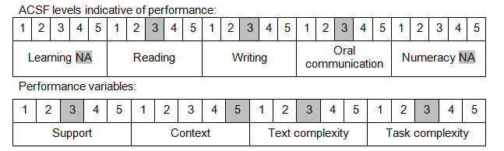

Further information on ACSF and the foundation skills underpinning this unit can be found in the Foundation Skills Guide on the GSA website.

Unit Mapping Information
This unit supersedes and is equivalent to DEFCA105 Operate and maintain armoured vehicle weapon systems.

Links
Companion Volume implementation guides are found in VETNet - https://vetnet.gov.au/Pages/TrainingDocs.aspx?q=6bdbab1e-11ed-4bc9-9cba-9e1a55d4e4a9
Companion Volume implementation guides are found in VETNet - https://vetnet.gov.au/Pages/TrainingDocs.aspx?q=6bdbab1e-11ed-4bc9-9cba-9e1a55d4e4a9
Companion Volume implementation guides are found in VETNet - https://vetnet.gov.au/Pages/TrainingDocs.aspx?q=6bdbab1e-11ed-4bc9-9cba-9e1a55d4e4a9

