DEFMIL022 Operate remote sensors to detect targets
Release: 1

DEFMIL022 Operate remote sensors to detect targets

Modification History
Release | Comments
1 | This unit was released in DEF Defence Training Package release 1.0 and meets the Standards for Training Packages.  This unit supersedes and is equivalent to DEFCA002B Operate remote sensors to detect targets.  - Unit code updated  - Content and formatting updated to comply with the new standards  - All PC transitioned from passive to active voice

Application
This unit describes the skills required to install sensors as directed by the operational plan in order to detect targets and to provide information to a remote control facility.
This unit was developed for those working in Defence as combat arms personnel required to install sensors as directed by the operational plan in order to detect targets and to provide information to a remote control facility in a deployed operational environment but is applicable to any individual in this field of work.
The skills and knowledge described in this unit must be applied within the legislative, regulatory and policy environment in which they are carried out. Organisational policies and procedures must be consulted and adhered to.
Those undertaking this unit would work as part of a team and will be under direct and/or indirect supervision. They would use discretion and judgement, and take responsibility for the quality of their outputs. They would perform specific tasks in a broad range of unpredictable contexts.
No licensing, legislative or certification requirements apply to unit at the time of publication.

Competency Field
Military Skills

Elements and Performance Criteria
ELEMENTS | PERFORMANCE CRITERIA
Elements describe the essential outcomes | Performance criteria describe the performance needed to demonstrate achievement of the element. Where bold italicised text is used, further information is detailed in the range of conditions section.
1. Prepare for operation | 1.1 Receive purpose and requirement of the surveillance activity from written or verbal instructions issued by supervisor.  1.2 Confirm task specifications and clarify where necessary with supervisor.  1.3 Identify and select surveillance equipment required for the task.  1.4 Check surveillance equipment for serviceability.
2. Prepare and maintain a location | 2.1 Occupy designated position, establish reference points and document information.  2.2 Deploy surveillance equipment.  2.3 Confirm optimal configuration with supervisor.  2.4 Test equipment to ensure functionality.  2.5 Camouflage site.  2.6 Maintain communications with stakeholders.  2.7 Conduct operational maintenance.

Foundation Skills
The foundation skills demands of this unit have been mapped for alignment with the Australian Core Skills Framework (ACSF). The following tables outline the performance levels indicated for successful attainment of the unit.

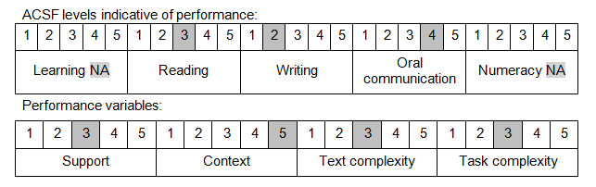

Further information on ACSF and the foundation skills underpinning this unit can be found in the Foundation Skills Guide on the GSA website.

Unit Mapping Information
This unit supersedes and is equivalent to DEFCA002B Operate remote sensors to detect targets.

Links
Companion Volume implementation guides are found in VETNet - https://vetnet.gov.au/Pages/TrainingDocs.aspx?q=6bdbab1e-11ed-4bc9-9cba-9e1a55d4e4a9
Companion Volume implementation guides are found in VETNet - https://vetnet.gov.au/Pages/TrainingDocs.aspx?q=6bdbab1e-11ed-4bc9-9cba-9e1a55d4e4a9
Companion Volume implementation guides are found in VETNet - https://vetnet.gov.au/Pages/TrainingDocs.aspx?q=6bdbab1e-11ed-4bc9-9cba-9e1a55d4e4a9

