DEFMIL011 Conduct individual and collective ceremonial drill
Release: 1

DEFMIL011 Conduct individual and collective ceremonial drill

Modification History
Release | Comments
1 | This unit was released in DEF Defence Training Package release 1.0 and meets the Standards for Training Packages.  This unit supersedes and is equivalent to DEFCM132 Conduct individual and collective ceremonial drill.  - Unit code updated  - Content and formatting updated to comply with the new standards  - All PC transitioned from passive to active voice

Application
This unit describes the skills required to supervise groups in the conduct of collective ceremonial drill movements and to perform specific individual drill movements with a cane, including:
- advance in review order
- change from slow to quick time and quick to slow time
- form two ranks from three and three ranks from two
- forms in slow and quick time
- march in line in slow and quick time
- open and close order on the march

Collective ceremonial drill fosters discipline, team work and a sense of collective identity while providing an appropriate means to physically commemorate the unique history, customs and traditions of military service.
This unit was developed for Defence personnel who are required to participate in and lead ceremonial drill, but is applicable to any individual in this field of work.
The skills and knowledge described in this unit must be applied within the legislative, regulatory and policy environment in which they are carried out. Organisational policies and procedures must be consulted and adhered to.
Those undertaking this unit would work independently. They use discretion and judgement, and take responsibility for the quality of their outputs. They would perform routine tasks in mainly predictable contexts.
No licensing, legislative or certification requirements apply to unit at the time of publication.

Competency Field
Military Skills

Elements and Performance Criteria
ELEMENTS | PERFORMANCE CRITERIA
Elements describe the essential outcomes | Performance criteria describe the performance needed to demonstrate achievement of the element. Where bold italicised text is used, further information is detailed in the range of conditions section.
1. Supervise collective ceremonial drill | 1.1 Identify appropriate type of collective ceremonial drill activity.  1.2 Plan for a collective ceremonial drill activity.  1.3 Conduct collective drill instruction in accordance with prescribed format.  1.4 Set and display standards of dress, bearing and collective drill movements.
2. Perform cane drill | 2.1 Rehearse cane drill movements and correct faults.  2.2 Perform cane drill movements in accordance with the manual.

Foundation Skills
The foundation skills demands of this unit have been mapped for alignment with the Australian Core Skills Framework (ACSF). The following tables outline the performance levels indicated for successful attainment of the unit.

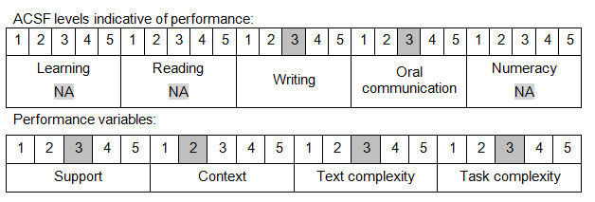

Further information on ACSF and the foundation skills underpinning this unit can be found in the Foundation Skills Guide on the GSA website.

Unit Mapping Information
This unit supersedes and is equivalent to DEFCM132 Conduct individual and collective ceremonial drill.

Links
Companion Volume implementation guides are found in VETNet - https://vetnet.gov.au/Pages/TrainingDocs.aspx?q=6bdbab1e-11ed-4bc9-9cba-9e1a55d4e4a9
Companion Volume implementation guides are found in VETNet - https://vetnet.gov.au/Pages/TrainingDocs.aspx?q=6bdbab1e-11ed-4bc9-9cba-9e1a55d4e4a9
Companion Volume implementation guides are found in VETNet - https://vetnet.gov.au/Pages/TrainingDocs.aspx?q=6bdbab1e-11ed-4bc9-9cba-9e1a55d4e4a9

