DEFMIL005 Operate a service hand grenade
Release: 1

DEFMIL005 Operate a service hand grenade

Modification History
Release | Comments
1 | This unit was released in DEF Defence Training Package release 1.0 and meets the Standards for Training Packages.  This unit supersedes and is equivalent to DEFCM103C Operate a service hand grenade.  - Unit code updated  - Content and formatting updated to comply with new standards  - All PC transitioned from passive to active voice  - Elements 1 and 2 merged  - All PC in elements 1 and 2 revised  - PC 3.2, 3.3 and 3.6 merged  - PC 3.4 and 3.5 removed

Application
This unit describes the skills required to operate a service hand grenade, which may include drill, high explosive, and practice grenades. This includes handling, maintaining, throwing the grenade and obtaining a satisfactory throwing accuracy.
This unit applies to those working as a member of the Australian Defence Force.
The skills and knowledge described in this unit must be applied within the legislative, regulatory and policy environment in which they are carried out. Organisational policies and procedures must be consulted and adhered to.
Those undertaking this unit would work under direct supervision, in accordance with the Rules of Engagement. They would perform specific tasks, in a broad range of contexts that could be unpredictable, focussing on applying safety requirements.
No licensing, legislative or certification requirements apply to unit at the time of publication.

Competency Field
Military Skills

Elements and Performance Criteria
ELEMENTS | PERFORMANCE CRITERIA
Elements describe the essential outcomes | Performance criteria describe the performance needed to demonstrate achievement of the element. Where bold italicised text is used, further information is detailed in the range of conditions section.
1. Handle and maintain a service hand grenade | 1.2 Identify and select service hand grenade in accordance with supervisor’s instructions and operational requirements.  1.3 Handle and carry service hand grenade.  1.4 Secure service hand grenade.  1.5 Clean service hand grenade.
2. Operate a service hand grenade | 2.1 Conduct grenade drills.  2.2 Throw the grenade after adopting throwing position and by applying throwing principles complying with Range Safety Brief and Practice Brief.

Foundation Skills
The foundation skills demands of this unit have been mapped for alignment with the Australian Core Skills Framework (ACSF). The following tables outline the performance levels indicated for successful attainment of the unit.
ACSF levels indicative of performance:
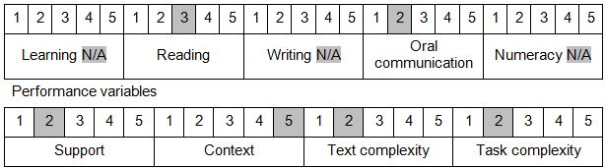

Further information on ACSF and the foundation skills underpinning this unit can be found in the Foundation Skills Guide on the GSA website.

Unit Mapping Information
This unit supersedes and is equivalent to DEFCM103C Operate a service hand grenade.

Links
Companion Volume implementation guides are found in VETNet - https://vetnet.gov.au/Pages/TrainingDocs.aspx?q=6bdbab1e-11ed-4bc9-9cba-9e1a55d4e4a9
Companion Volume implementation guides are found in VETNet - https://vetnet.gov.au/Pages/TrainingDocs.aspx?q=6bdbab1e-11ed-4bc9-9cba-9e1a55d4e4a9
Companion Volume implementation guides are found in VETNet - https://vetnet.gov.au/Pages/TrainingDocs.aspx?q=6bdbab1e-11ed-4bc9-9cba-9e1a55d4e4a9

