DEFMIL004 Operate a light support weapon
Release: 1

DEFMIL004 Operate a light support weapon

Modification History
Release | Comments
1 | This unit was released in DEF Defence Training Package release 1.0 and meets the Standards for Training Packages.  This unit supersedes and is equivalent to DEFCM102C Operate a light support weapon.  - Unit code updated  - Content and formatting updated to comply with new standards  - All PC transitioned from passive to active voice  - PC 1.1 and 4.2 removed

Application
This unit describes the skills required to operate a light support weapon. This includes handling, maintaining, operating and firing the light support weapon and obtaining satisfactory engagement accuracy. The light support weapon would usually be carried and fired from the shoulder.
This unit applies to those working as a member of the Australian Defence Force.
The skills and knowledge described in this unit must be applied within the legislative, regulatory and policy environment in which they are carried out. Organisational policies and procedures must be consulted and adhered to.
Those undertaking this unit would work under direct supervision, in accordance with the Rules of Engagement. They would perform specific tasks, in a broad range of contexts that could be unpredictable, focussing on applying safety requirements.
No licensing, legislative or certification requirements apply to unit at the time of publication.

Competency Field
Military Skills

Elements and Performance Criteria
ELEMENTS | PERFORMANCE CRITERIA
Elements describe the essential outcomes | Performance criteria describe the performance needed to demonstrate achievement of the element. Where bold italicised text is used, further information is detailed in the range of conditions section.
1. Handle a light support weapon | 1.1 Handle and carry light support weapon.  1.2 Identify, select and handle ammunition.  1.3 Secure light support weapon.
2. Maintain a light support weapon | 2.1 Strip and assemble light support weapon.  2.2 Clean light support weapon and associated equipment.  2.3 Clean, inspect, carry and secure ammunition.  2.4 Identify and rectify defects within limits of authority or report to supervisor.  2.5 Complete documentation.
3. Operate a light support weapon | 3.1 Fill and empty light support weapon magazine.  3.2 Conduct weapon drills.  3.3 Apply marksmanship principles.  3.4 Adopt fire positions according to environment and threat.  3.5 Employ weapon equipment.
4. Fire a light support weapon | 4.1 Fire light support weapon.  4.2 Identify and engage targets.  4.3 Comply with safety brief and/or practice brief when firing the weapon.

Foundation Skills
The foundation skills demands of this unit have been mapped for alignment with the Australian Core Skills Framework (ACSF). The following tables outline the performance levels indicated for successful attainment of the unit.
ACSF levels indicative of performance:
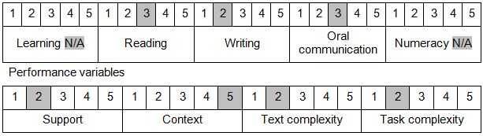

Further information on ACSF and the foundation skills underpinning this unit can be found in the Foundation Skills Guide on the GSA website.

Unit Mapping Information
This unit supersedes and is equivalent to DEFCM102C Operate a light support weapon.

Links
Companion Volume implementation guides are found in VETNet - https://vetnet.gov.au/Pages/TrainingDocs.aspx?q=6bdbab1e-11ed-4bc9-9cba-9e1a55d4e4a9
Companion Volume implementation guides are found in VETNet - https://vetnet.gov.au/Pages/TrainingDocs.aspx?q=6bdbab1e-11ed-4bc9-9cba-9e1a55d4e4a9
Companion Volume implementation guides are found in VETNet - https://vetnet.gov.au/Pages/TrainingDocs.aspx?q=6bdbab1e-11ed-4bc9-9cba-9e1a55d4e4a9

