DEFMIL003 Operate a service rifle
Release: 1

DEFMIL003 Operate a service rifle

Modification History
Release | Comments
1 | This unit was released in DEF Defence Training Package release 1.0 and meets the Standards for Training Packages.  This unit supersedes and is equivalent to DEFCM101C Operate a service rifle.  - Unit code updated  - Content and formatting updated to comply with new standards  - All PC transitioned from passive to active voice  - PC 1.1 and 1.4 removed  - PC 4.1 and 4.2 merged

Application
This unit covers the competency required to operate any current in service rifle. Operating a service rifle involves the ability to safely handle, maintain, operate and fire the service rifle.
This unit applies to those working as a member of the Australian Defence Force.
The skills and knowledge described in this unit must be applied within the legislative, regulatory and policy environment in which they are carried out. Organisational policies and procedures must be consulted and adhered to.
Those undertaking this unit would work under direct supervision, in accordance with the Rules of Engagement. They would perform specific tasks, in a broad range of contexts, focussing on applying safety requirements.
No licensing, legislative or certification requirements apply to unit at the time of publication.

Competency Field
Military Skills

Elements and Performance Criteria
ELEMENTS | PERFORMANCE CRITERIA
Elements describe the essential outcomes | Performance criteria describe the performance needed to demonstrate achievement of the element. Where bold italicised text is used, further information is detailed in the range of conditions section.
1. Handle a service rifle | 1.1 Handle and carry service rifle.  1.2 Identify, select and handle ammunition.
2. Maintain a service rifle | 2.1 Strip and assemble service rifle.  2.2 Clean and service rifle and associated equipment as required.  2.3 Clean, inspect, carry and secure ammunition.  2.4 Identify and rectify defects within limits of authority or report to supervisor.  2.5 Complete documentation.
3. Operate a service rifle | 3.1 Fill and empty service rifle magazine.  3.2 Conduct weapon drills.  3.3 Apply marksmanship principles.  3.4 Adopt fire positions as required by environment and threat.  3.5 Employ weapon equipment.
4. Fire a service rifle | 4.1 Fire service rifle complying with Range Safety Brief and Practice Brief.  4.2 Identify and engage targets.

Foundation Skills
The foundation skills demands of this unit have been mapped for alignment with the Australian Core Skills Framework (ACSF). The following tables outline the performance levels indicated for successful attainment of the unit.
ACSF levels indicative of performance:
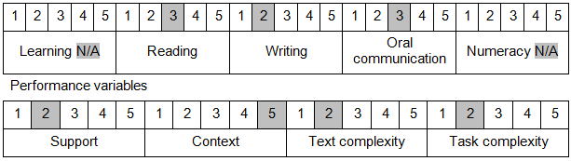

Further information on ACSF and the foundation skills underpinning this unit can be found in the Foundation Skills Guide on the GSA website.

Unit Mapping Information
This unit supersedes and is equivalent to DEFCM101C Operate a service rifle.

Links
Companion Volume implementation guides are found in VETNet - https://vetnet.gov.au/Pages/TrainingDocs.aspx?q=6bdbab1e-11ed-4bc9-9cba-9e1a55d4e4a9
Companion Volume implementation guides are found in VETNet - https://vetnet.gov.au/Pages/TrainingDocs.aspx?q=6bdbab1e-11ed-4bc9-9cba-9e1a55d4e4a9
Companion Volume implementation guides are found in VETNet - https://vetnet.gov.au/Pages/TrainingDocs.aspx?q=6bdbab1e-11ed-4bc9-9cba-9e1a55d4e4a9

