DEFLAW010 Perform the duties of an appointing officer
Release: 1

DEFLAW010 Perform the duties of an appointing officer

Modification History
Release | Comments
1 | This unit was released in DEF Defence Training Package release 1.0 and meets the Standards for Training Packages.  This unit supersedes and is equivalent to DEFCM129A Perform the duties of an appointing officer.  - Unit code updated  - Content and formatting updated to comply with new standards  - All PC transitioned from passive to active voice  - PC 1.1 removed  - PC 2.2 revised

Application
This unit describes the skills required to appoint an inquiry officer and/or inquiry assistant in relation to a Defence matter under his/her command or control.
This unit applies to those working as appointing officers that may be:
- Defence Force commanding officer
- officer who has the powers of a formation commander under the Australian Military Regulations 1927
- officer who holds an appointment superior to that of an officer mentioned in the above two points

The skills and knowledge described in this unit must be applied within the legislative, regulatory and policy environment in which they are carried out. Organisational policies and procedures must be consulted and adhered to.
Those undertaking this unit would work autonomously, while performing sophisticated tasks in a broad range of contexts.
No licensing, legislative or certification requirements apply to unit at the time of publication.

Competency Field
Military Justice

Elements and Performance Criteria
ELEMENTS | PERFORMANCE CRITERIA
Elements describe the essential outcomes | Performance criteria describe the performance needed to demonstrate achievement of the element. Where bold italicised text is used, further information is detailed in the range of conditions section.
1. Appoint an inquiry | 1.1 Ensure a quick assessment (QA) is completed.  1.2 Produce instrument of appointment and Terms of Reference.  1.3 Monitor inquiry report.
2. Action the inquiry report | 2.1 Receive inquiry report and confirm against the Terms of Reference.  2.2 Consult subject matter experts.  2.3 Accept or reject findings and recommendations of the inquiry report.  2.4 Implement accepted recommendations.  2.5 Notify stakeholders.  2.6 Complete documentation.

Foundation Skills
The foundation skills demands of this unit have been mapped for alignment with the Australian Core Skills Framework (ACSF). The following tables outline the performance levels indicated for successful attainment of the unit.
ACSF levels indicative of performance:
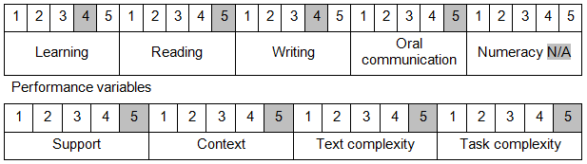

Further information on ACSF and the foundation skills underpinning this unit can be found in the Foundation Skills Guide on the GSA website.

Unit Mapping Information
This unit supersedes and is equivalent to DEFCM129A Perform the duties of an appointing officer.

Links
Companion Volume implementation guides are found in VETNet - https://vetnet.gov.au/Pages/TrainingDocs.aspx?q=6bdbab1e-11ed-4bc9-9cba-9e1a55d4e4a9
Companion Volume implementation guides are found in VETNet - https://vetnet.gov.au/Pages/TrainingDocs.aspx?q=6bdbab1e-11ed-4bc9-9cba-9e1a55d4e4a9
Companion Volume implementation guides are found in VETNet - https://vetnet.gov.au/Pages/TrainingDocs.aspx?q=6bdbab1e-11ed-4bc9-9cba-9e1a55d4e4a9

