DEFLAW009 Make a Defence administrative decision
Release: 1

DEFLAW009 Make a Defence administrative decision

Modification History
Release | Comments
1 | This unit was released in DEF Defence Training Package release 1.0 and meets the Standards for Training Packages.  This unit supersedes and is equivalent to DEFCM128A Make a Defence administrative decision.  - Unit code updated  - Content and formatting updated to comply with new standards  - All PC transitioned from passive to active voice  - PC 1.2 removed  - PC 2.1 revised

Application
This unit describes the skills required to manage quick assessment (QA) inquiries and to make administrative decisions that may adversely affect members’ rights, interests and expectations and that are within the discretion of the commanding officer (CO) to make.
This unit applies to those working as Defence members who have been given command, either as an automatic consequence of appointment, or by an instrument of appointment, as a CO or as an administrative CO; in some circumstances it is by rank only, irrespective of the position held.
The skills and knowledge described in this unit must be applied within the legislative, regulatory and policy environment in which they are carried out. Organisational policies and procedures must be consulted and adhered to.
Those undertaking this unit would work autonomously, while performing sophisticated tasks in a broad range of contexts.
No licensing, legislative or certification requirements apply to unit at the time of publication.

Competency Field
Military Justice

Elements and Performance Criteria
ELEMENTS | PERFORMANCE CRITERIA
Elements describe the essential outcomes | Performance criteria describe the performance needed to demonstrate achievement of the element. Where bold italicised text is used, further information is detailed in the range of conditions section.
1. Prepare to make an administrative decision | 1.1 Determine initial action.  1.2 Instigate quick assessment.  1.3 Initiate administrative sanction.
2. Make an administrative decision | 2.1 Assess factors.  2.2 Make administrative decision.  2.3 Inform stakeholders of the decision and its reasons.  2.4 Complete documentation.

Foundation Skills
The foundation skills demands of this unit have been mapped for alignment with the Australian Core Skills Framework (ACSF). The following tables outline the performance levels indicated for successful attainment of the unit.
ACSF levels indicative of performance:
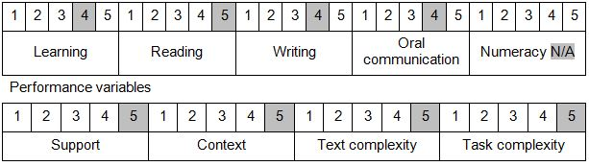

Further information on ACSF and the foundation skills underpinning this unit can be found in the Foundation Skills Guide on the GSA website.

Unit Mapping Information
This unit supersedes and is equivalent to DEFCM128A Make a Defence administrative decision.

Links
Companion Volume implementation guides are found in VETNet - https://vetnet.gov.au/Pages/TrainingDocs.aspx?q=6bdbab1e-11ed-4bc9-9cba-9e1a55d4e4a9
Companion Volume implementation guides are found in VETNet - https://vetnet.gov.au/Pages/TrainingDocs.aspx?q=6bdbab1e-11ed-4bc9-9cba-9e1a55d4e4a9
Companion Volume implementation guides are found in VETNet - https://vetnet.gov.au/Pages/TrainingDocs.aspx?q=6bdbab1e-11ed-4bc9-9cba-9e1a55d4e4a9

