DEFLAW006 Conduct summary authority proceedings
Release: 1

DEFLAW006 Conduct summary authority proceedings

Modification History
Release | Comments
1 | This unit was released in DEF Defence Training Package release 1.0 and meets the Standards for Training Packages.  This unit supersedes and is equivalent to DEFCM125A Conduct summary authority proceedings.  - Unit code updated  - Content and formatting updated to comply with new standards  - All PC transitioned from passive to active voice  - PC 1.1 removed

Application
This unit describes the skills required to conduct service summary trials under the Defence Force Discipline Act (DFDA). These proceedings may include subordinate summary, summary, superior summary.
This unit applies to those working as Defence members who are summary authorities either as an automatic consequence of appointment (such as command) or by an instrument of appointment.
The skills and knowledge described in this unit must be applied within the legislative, regulatory and policy environment in which they are carried out. Organisational policies and procedures must be consulted and adhered to.
Those undertaking this unit would work autonomously with legal support, while performing sophisticated tasks in a broad range of contexts.
No licensing, legislative or certification requirements apply to unit at the time of publication.

Competency Field
Military Justice

Elements and Performance Criteria
ELEMENTS | PERFORMANCE CRITERIA
Elements describe the essential outcomes | Performance criteria describe the performance needed to demonstrate achievement of the element. Where bold italicised text is used, further information is detailed in the range of conditions section.
1. Conduct summary trials | 1.1 Determine jurisdiction.  1.2 Make a determination by assessing applications and objections.  1.3 Conduct trial proceedings.  1.4 Assess evidence, examine trial documentation and seek clarification.  1.5 Determine guilt or innocence and give a judgement.  1.6 Listen to, interpret and determine validity of plea/s.  1.7 Listen to and interpret prosecutorial advice and mitigation.  1.8 Impose punishment/s and provide reasons.
2. Complete post-trial requirements | 2.1 Conduct post-trial procedures.  2.2 Complete, process and store post-trial documentation.

Foundation Skills
The foundation skills demands of this unit have been mapped for alignment with the Australian Core Skills Framework (ACSF). The following tables outline the performance levels indicated for successful attainment of the unit.
ACSF levels indicative of performance:
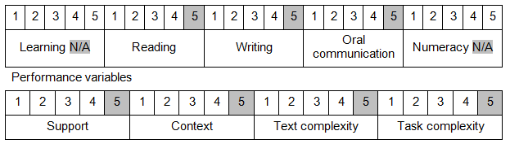

Further information on ACSF and the foundation skills underpinning this unit can be found in the Foundation Skills Guide on the GSA website.

Unit Mapping Information
This unit supersedes and is equivalent to DEFCM125A Conduct summary authority proceedings.

Links
Companion Volume implementation guides are found in VETNet - https://vetnet.gov.au/Pages/TrainingDocs.aspx?q=6bdbab1e-11ed-4bc9-9cba-9e1a55d4e4a9
Companion Volume implementation guides are found in VETNet - https://vetnet.gov.au/Pages/TrainingDocs.aspx?q=6bdbab1e-11ed-4bc9-9cba-9e1a55d4e4a9
Companion Volume implementation guides are found in VETNet - https://vetnet.gov.au/Pages/TrainingDocs.aspx?q=6bdbab1e-11ed-4bc9-9cba-9e1a55d4e4a9

