DEFLAW003 Provide advice on service administrative law
Release: 1

DEFLAW003 Provide advice on service administrative law

Modification History
Release | Comments
1 | This unit was released in DEF Defence Training Package release 1.0 and meets the Standards for Training Packages.  This unit supersedes and is equivalent to DEFCM122A Provide advice on service administrative law.  - Unit code updated  - Content and formatting updated to comply with new standards  - All PC transitioned from passive to active voice  - PC 2.2 and 2.3 merged

Application
This unit describes the skills required to provide advice to subordinates on the procedural aspects and practical application of service administrative law as it relates to the Australian Defence Force (ADF). This is to assist supervisors in the following situations:
- reviewing administrative sanctions
- reviewing the Notice to Show Cause process
- drafting a regress of grievance
- listing common administrative law references
- reviewing administrative law principles
- outlining how administrative law processes apply to common ADF policies such as illicit drugs, equity and diversity, harassment and bullying, sexual harassment, alcohol abuse

This unit applies to those working as members of the ADF.
The skills and knowledge described in this unit must be applied within the legislative, regulatory and policy environment in which they are carried out. Organisational policies and procedures must be consulted and adhered to.
Those undertaking this unit must have authority to act independently, have or will have responsibility for subordinates, would work under the commander’s direction, while performing complex tasks in a broad range of contexts.
No licensing, legislative or certification requirements apply to unit at the time of publication.

Competency Field
Military Justice

Elements and Performance Criteria
ELEMENTS | PERFORMANCE CRITERIA
Elements describe the essential outcomes | Performance criteria describe the performance needed to demonstrate achievement of the element. Where bold italicised text is used, further information is detailed in the range of conditions section.
1. Plan and prepare to provide advice on service administrative law | 1.1 Identify circumstances that require the provision of advice on service administrative law.  1.2 Analyse circumstances and conduct research within the scope of own responsibility.  1.3 Locate and interpret guidance in relevant administrative law organisational policy documents.
2. Provide information on service administrative law | 2.1 Identify and explain policy references on common administrative law issues to subordinates.  2.2 Explain procedures on common administrative law issues and administrative law principles to subordinates.  2.3 Provide assistance to subordinates in preparing common administrative law documents.

Foundation Skills
The foundation skills demands of this unit have been mapped for alignment with the Australian Core Skills Framework (ACSF). The following tables outline the performance levels indicated for successful attainment of the unit.
ACSF levels indicative of performance:
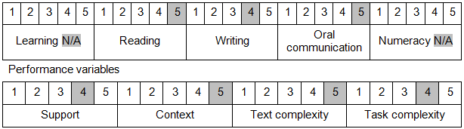

Further information on ACSF and the foundation skills underpinning this unit can be found in the Foundation Skills Guide on the GSA website.

Unit Mapping Information
This unit supersedes and is equivalent to DEFCM122A Provide advice on service administrative law.

Links
Companion Volume implementation guides are found in VETNet - https://vetnet.gov.au/Pages/TrainingDocs.aspx?q=6bdbab1e-11ed-4bc9-9cba-9e1a55d4e4a9
Companion Volume implementation guides are found in VETNet - https://vetnet.gov.au/Pages/TrainingDocs.aspx?q=6bdbab1e-11ed-4bc9-9cba-9e1a55d4e4a9
Companion Volume implementation guides are found in VETNet - https://vetnet.gov.au/Pages/TrainingDocs.aspx?q=6bdbab1e-11ed-4bc9-9cba-9e1a55d4e4a9

