DEFGEN026 Manage engineering and logistic operations
Release: 1

DEFGEN026 Manage engineering and logistic operations

Modification History
Release | Comments
1 | This unit was released in DEF Defence Training Package release 1.0 and meets the Standards for Training Packages.

Application
This unit describes the skills required to plan and manage engineering and logistic operations. It involves developing and delivering orders and instructions, identifying the application of legislative requirements, coordinating multiple activities and providing debriefing, reports and appropriate documentation associated with the operations.
This unit applies to those required to manage a number of engineering and logistic processes, such as a manager of explosive ordnance operations.
The skills and knowledge described in this unit must be applied within the legislative, regulatory and policy environment in which they are carried out. Organisational policies and procedures must be consulted and adhered to.
Those undertaking this unit will have some autonomy of action, may delegate authority to subordinates and will be capable of independent decision making, requiring no supervision. They would perform complex tasks in a broad range of contexts.
No licensing, legislative or certification requirements apply to unit at the time of publication.

Competency Field
General

Elements and Performance Criteria
ELEMENTS | PERFORMANCE CRITERIA
Elements describe the essential outcomes | Performance criteria describe the performance needed to demonstrate achievement of the element. Where bold italicised text is used, further information is detailed in the range of conditions section.
1. Identify operational requirements and feasibility | 1.1 Allocate operational requirements and determine constraints imposed and any special requirements.  1.2 Identify doctrine, policies and procedures applying to the operation.  1.3 Assess feasibility of the operations to be undertaken, identifying areas of coordination and impact on others and identify issues of concern and shortfalls.  1.4 Report identified concerns and shortfalls to the chain of command.
2. Plan and prepare for conduct of operations | 2.1 Plan method of conducting operations, including contingency arrangements.  2.2 Acquire resources required for the task, such as facilities, tools, equipment, materials, drawings, work procedures and other documentation.  2.3 Adjust plans and schedules in accordance with available resources  2.4 Assess resources for suitability and report defects/shortfalls.  2.5 Ensure finances are available for the operation.  2.6 Confirm staffing requirements and, if required, develop and implement a recruiting plan.  2.7 Finalise, authorise and distribute plan.
3. Manage operations | 3.1 Brief the task controllers on the planned activity which will included details such as their mission, tasks, resources production requirements, and delegated authority.  3.2 Manage and monitor operations to ensure efficiency of performance, quality of production and objectives are achieved.  3.3 Modify plans during the operation to reflect changing circumstances, such as changes to requirements in effort, resources and support.  3.4 Coordinate operations, reallocating/adjusting resources to meet operational requirements.  3.5 Liaise with stakeholders throughout the operation ensuring feedback and performance are addressed.  3.6 Ascertain support requirements and either provide or request.  3.7 Refer issues that cannot be resolved to the chain of command.
4. Conclude operations | 4.1 Coordinate the refurbishment of the task area, tools, materials and equipment.  4.2 Debrief controllers on the conduct of the operation.  4.3 Complete documentation associated with the operation.

Foundation Skills
The foundation skills demands of this unit have been mapped for alignment with the Australian Core Skills Framework (ACSF). The following tables outline the performance levels indicated for successful attainment of the unit.

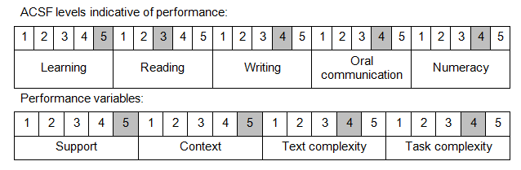

Further information on ACSF and the foundation skills underpinning this unit can be found in the Foundation Skills Guide on the GSA website.

Unit Mapping Information
No equivalent unit.

Links
Companion Volume implementation guides are found in VETNet - https://vetnet.gov.au/Pages/TrainingDocs.aspx?q=6bdbab1e-11ed-4bc9-9cba-9e1a55d4e4a9
Companion Volume implementation guides are found in VETNet - https://vetnet.gov.au/Pages/TrainingDocs.aspx?q=6bdbab1e-11ed-4bc9-9cba-9e1a55d4e4a9
Companion Volume implementation guides are found in VETNet - https://vetnet.gov.au/Pages/TrainingDocs.aspx?q=6bdbab1e-11ed-4bc9-9cba-9e1a55d4e4a9

