DEFGEN025 Control engineering and logistic processes
Release: 1

DEFGEN025 Control engineering and logistic processes

Modification History
Release | Comments
1 | This unit was released in DEF Defence Training Package release 1.0 and meets the Standards for Training Packages.

Application
This unit describes the skills required to control teams involved in engineering and logistic operations. It includes planning the task, applying safety precautions, identifying requirements and resources, and controlling the operation.
This unit applies to those required to control a number of work teams involved in engineering and logistic operations, for example, a controller of explosive ordnance operations.
The skills and knowledge described in this unit must be applied within the legislative, regulatory and policy environment in which they are carried out. Organisational policies and procedures must be consulted and adhered to.
Those undertaking this unit will have some authority and influence in the chain of command/authority, being capable of independent decision making, requiring only routine supervision. They would perform complex tasks in a broad range of contexts.
No licensing, legislative or certification requirements apply to unit at the time of publication.

Competency Field
General

Elements and Performance Criteria
ELEMENTS | PERFORMANCE CRITERIA
Elements describe the essential outcomes | Performance criteria describe the performance needed to demonstrate achievement of the element. Where bold italicised text is used, further information is detailed in the range of conditions section.
1. Identify operational requirements and allocated resources | 1.1 Allocate tasks and resources and determine constraints imposed and any special requirements.  1.2 Identify doctrine, policies and procedures applying to the task.  1.3 Analyse the task to identify issues of concern and shortfalls.  1.4 Report identified concerns and shortfalls to the chain of command.
2. Plan for operation | 2.1 Plan method of performing the operation including contingency arrangements.  2.2 Acquire resources required for the task, such as facilities, tools, equipment, materials, drawings, work procedures and other documentation.  2.3 Assess resources for suitability and report defects/shortfalls.  2.4 Brief team supervisors on the plan.
3. Control the operation | 3.1 Monitor operation to ensure efficiency of performance and objectives are achieved.  3.2 Coordinate operations and allocate resources to meet requirements.  3.3 Liaise with and coordinate stakeholders.  3.4 Ascertain and address support requirements.  3.5 Refer issues that cannot be resolved to the chain of command.
4. Conclude processes | 4.1 Refurbish task area, tools, materials and equipment.  4.2 Debrief supervisors on the performance of their processes.  4.3 Complete documentation associated with the task.

Foundation Skills
The foundation skills demands of this unit have been mapped for alignment with the Australian Core Skills Framework (ACSF). The following tables outline the performance levels indicated for successful attainment of the unit.

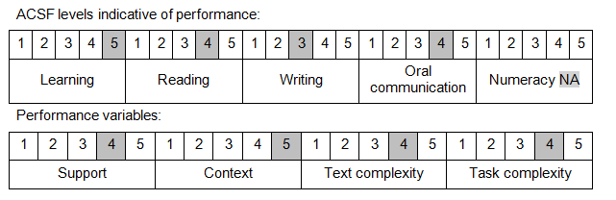

Further information on ACSF and the foundation skills underpinning this unit can be found in the Foundation Skills Guide on the GSA website.

Unit Mapping Information
No equivalent unit.

Links
Companion Volume implementation guides are found in VETNet - https://vetnet.gov.au/Pages/TrainingDocs.aspx?q=6bdbab1e-11ed-4bc9-9cba-9e1a55d4e4a9
Companion Volume implementation guides are found in VETNet - https://vetnet.gov.au/Pages/TrainingDocs.aspx?q=6bdbab1e-11ed-4bc9-9cba-9e1a55d4e4a9
Companion Volume implementation guides are found in VETNet - https://vetnet.gov.au/Pages/TrainingDocs.aspx?q=6bdbab1e-11ed-4bc9-9cba-9e1a55d4e4a9

