DEFGEN024 Supervise engineering and logistic tasks
Release: 1

DEFGEN024 Supervise engineering and logistic tasks

Modification History
Release | Comments
1 | This unit was released in DEF Defence Training Package release 1.0 and meets the Standards for Training Packages.

Application
This unit describes the skills required to supervise a team involved in engineering and logistic tasks. It includes planning the task, applying safety precautions, identifying requirements and resources, and supervising the performance of the task.
This unit applies to those supervising a team activity requiring engineering and logistic tasks.
The skills and knowledge described in this unit must be applied within the legislative, regulatory and policy environment in which they are carried out. Organisational policies and procedures must be consulted and adhered to.
Those undertaking this unit would supervise small teams, using discretion and judgement and taking responsibility for the quality of their outputs. They would perform specific tasks in a range of contexts that could be unpredictable.
No licensing, legislative or certification requirements apply to unit at the time of publication.

Competency Field
General

Elements and Performance Criteria
ELEMENTS | PERFORMANCE CRITERIA
Elements describe the essential outcomes | Performance criteria describe the performance needed to demonstrate achievement of the element. Where bold italicised text is used, further information is detailed in the range of conditions section.
1. Identify task requirements and allocated resources | 1.1 Receive task requirements and determine constraints imposed and any special requirements.  1.2 Identify doctrine, policies and procedures applying to the task.  1.3 Analyse the task to identify issues of concern and shortfalls.  1.4 Report identified concerns and shortfalls to the chain of command.
2. Plan and prepare for task | 2.1 Plan method of performing the task, including contingency arrangements.  2.2 Identify personnel to be employed in the process, and ensure they are competent for the task.  2.3 Acquire resources required for the task, such as materials, drawings, work procedures and other documentation.  2.4 Assess resources for suitability and report defects/shortfalls.  2.5 Conduct task briefings.
3. Supervise task | 3.1 Oversee observance of appropriate operational and WHS requirements/safety precautions.  3.2 Ensure efficiency in performance and mission is achieved.  3.3 Ascertain support requirements and either provide or request.  3.4 Refer issues that cannot be resolved to the chain of command.
4. Finalise task | 4.1 Refurbish task area, tools, materials and equipment.  4.2 Complete documentation associated with the task.

Foundation Skills
The foundation skills demands of this unit have been mapped for alignment with the Australian Core Skills Framework (ACSF). The following tables outline the performance levels indicated for successful attainment of the unit.

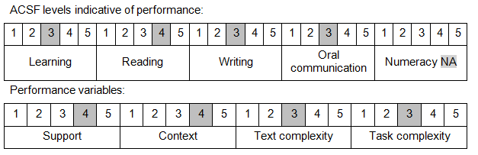

Further information on ACSF and the foundation skills underpinning this unit can be found in the Foundation Skills Guide on the GSA website.

Unit Mapping Information
No equivalent unit.

Links
Companion Volume implementation guides are found in VETNet - https://vetnet.gov.au/Pages/TrainingDocs.aspx?q=6bdbab1e-11ed-4bc9-9cba-9e1a55d4e4a9
Companion Volume implementation guides are found in VETNet - https://vetnet.gov.au/Pages/TrainingDocs.aspx?q=6bdbab1e-11ed-4bc9-9cba-9e1a55d4e4a9
Companion Volume implementation guides are found in VETNet - https://vetnet.gov.au/Pages/TrainingDocs.aspx?q=6bdbab1e-11ed-4bc9-9cba-9e1a55d4e4a9

